|  |  |  |  |  |  |  |  |
| --- | --- | --- | --- | --- | --- | --- | --- |
| **UNIVERSITY OF TRANSPORT AND COMMUNICATIONS**  **FACULTY OF INTERNATIONAL EDUCATION**  F:\RESEARCH\CONFERENCES\Conference INED\logo\Logo GTVT.jpg F:\RESEARCH\CONFERENCES\Conference INED\logo\17496124_1471848959493474_450831252_n.jpg    **GRADUATION PROJECT**  High-Quality Program of English – Vietnamese  Information Technology  **Topic**  **LEARN UI/UX PRINCIPLES AND APPLY IN REDESIGNING AND BUILDING DEGREY WEBSITE**  by   |  | | --- | | **PHAM NGOC HAI** |   COURSE 61  CLASS 1    **HANOI - JUNE 2024**  **UNIVERSITY OF TRANSPORT AND COMMUNICATIONS**  **FACULTY OF INTERNATIONAL EDUCATION**  F:\RESEARCH\CONFERENCES\Conference INED\logo\Logo GTVT.jpg F:\RESEARCH\CONFERENCES\Conference INED\logo\17496124_1471848959493474_450831252_n.jpg  **GRADUATION PROJECT**  Submitted in partial fulfillment of the requirements for the degree of engineer   |  | | --- | | High-Quality Program of English – Vietnamese  Information Technology |   by   |  | | --- | | **PHAM NGOC HAI** |  |  |  | | --- | --- | | Under supervision of | Dr. NGUYEN QUOC TUAN | | Examiner of | Dr. …………………………… |     **HA NOI - JUNE 2024**  **COMMENT OF SUPERVISOR**   1. **EVALUATION OF CONTENT AND QUALITY OF REPORT:**              1. **EVALUATION OF CONTENT AND QUALITY OF CODE//PROGRAMS:**              1. **EVALUATION OF WORKING ATTITUDE OF STUDENT:**              1. **CONCLUSION:**              1. **MARK:**   ......................../10.  *Hanoi, June 2024*  MAIN SUPERVISOR  **COMMENT OF REVIEWER**   1. **EVALUATION OF CONTENT AND QUALITY OF REPORT:**              1. **EVALUATION OF CONTENT AND QUALITY OF CODE/PROGRAMS:**              1. **CONCLUSION:**                        1. **MARK:**   ......................../10.  *Hanoi, June 2024*  REVIEWER |

# ACKNOWLEDGEMENT

In order this project to achieve the current good results, I have received a lot of support and guidance from teacher Nguyen Quoc Tuan. Out of sincerity, I would like to express my deepest gratitude to you.

In addition, throughout the process of studying and researching, I also received help and support from teachers in the department and classmates. I would like to thank my teachers and friends very much!

Besides, I would also like to thank the teachers and school for creating the best conditions for me to have the best learning environment.

I respectfully wish all teachers and schools always be healthy!

**Thank you sincerely!**

Ha Noi, June 6th, 2024

Student working

Pham Ngoc Hai

# TABLE OF CONTENTS

[ACKNOWLEDGEMENT…………………………………………………………………… 5](#_Toc168650993)

[TABLE OF CONTENTS……………………………………………………………………..6](#_Toc168650994)

[LIST OF FIGURES………………………………………………………………………….. 8](#_Toc168650995)

[LIST OF TABLES………………………………………………………………………….. 10](#_Toc168650996)

[CHAPTER 1 : INTRODUCTION……………………………………………………… 11](#_Toc168650997)

[1.1 Problem Statement………………………………………………………………... 11](#_Toc168650998)

[1.1.1 Problem Introduction………………………………………………………… 11](#_Toc168650999)

[1.1.2 Problem Review……………………………………………………………… 11](#_Toc168651000)

[1.1.3 Problem Solving……………………………………………………………… 13](#_Toc168651001)

[1.2 Technology Used…………………………………………………………………... 14](#_Toc168651002)

[1.2.1 Figma design tool…………………………………………………………….. 14](#_Toc168651003)

[1.2.2 SQL Server Database………………………………………………………… 16](#_Toc168651006)

[1.2.3 Framework Bootstrap………………………………………………………… 17](#_Toc168651009)

[1.2.4 C# programming language and ASP.Net Core framework…………………... 19](#_Toc168651012)

[CHAPTER 2 : SERVEY AND ANALYZE SYSTEM DESIGN……………………… 22](#_Toc168651016)

[2.1 System survey……………………………………………………………………… 22](#_Toc168651017)

[2.1.1 Survey user needs using the User Centered Design method…………………. 22](#_Toc168651018)

[2.1.2 Surveys are available………………………………………………………… 25](#_Toc168651019)

[2.2 The expected features compared to similar websites…………………………… 26](#_Toc168651020)

[2.2.1 Similar websites……………………………………………………………… 26](#_Toc168651021)

[2.2.2 Compared features with similar websites……………………………………. 28](#_Toc168651022)

[2.3 System description………………………………………………………………… 29](#_Toc168651023)

[2.3.1 Use Case Analysis……………………………………………………………. 29](#_Toc168651024)

[2.3.2 Sequence diagram……………………………………………………………. 36](#_Toc168651025)

[2.3.3 Database design………………………………………………………………. 38](#_Toc168651026)

[CHAPTER 3 : BUILD THE PROGRAM……………………………………………… 44](#_Toc168651027)

[3.1 System interface design…………………………………………………………… 44](#_Toc168651028)

[3.1.1 Homepage Interface………………………………………………………….. 44](#_Toc168651029)

[3.1.2 Shop Interface (Products)…………………………………………………….. 46](#_Toc168651030)

[3.1.3 Product Detail Interface……………………………………………………… 47](#_Toc168651031)

[3.1.4 Shopping Cart Interface……………………………………………………… 48](#_Toc168651032)

[3.1.5 Checkout Interface…………………………………………………………… 48](#_Toc168651033)

[3.1.6 Store interface………………………………………………………………... 49](#_Toc168651034)

[3.1.7 About Us Interface…………………………………………………………… 50](#_Toc168651035)

[3.2 Install application…………………………………………………………………. 51](#_Toc168651036)

[3.2.1 Install Project Nuget Packages……………………………………………….. 52](#_Toc168651037)

[3.2.2 The order placing feature as user…………………………………………….. 53](#_Toc168651038)

[3.2.3 Order payment via VNPay…………………………………………………… 56](#_Toc168651039)

[3.3 Results……………………………………………………………………………… 59](#_Toc168651040)

[3.3.1 Admin pages (Admin)………………………………………………………... 59](#_Toc168651041)

[3.3.2 Client page (Customers, Guests)……………………………………………... 61](#_Toc168651042)

[CONCLUSION……………………………………………………………………………… 66](#_Toc168651043)

[REFERENCES……………………………………………………………………………… 67](#_Toc168651044)

# LIST OF FIGURES

[**Figure 1.1** Degrey website / Source: degrey.vn 12](#_Toc168650204)

[**Figure 1.2** Nowsaigon website / Source: nowsaigon.vn 12](#_Toc168650205)

[**Figure 1.3** Figma design tool 14](#_Toc168650206)

[**Figure 1.4** SQL Sever database 16](#_Toc168650207)

[**Figure 1.5** Boostrap Framework 17](#_Toc168650208)

[**Figure 1.6** C# programming language 19](#_Toc168650209)

[**Figure 1.7**  Framework ASP.NET Core 20](#_Toc168650210)

[**Figure 2.1** User Center Design Convas / Source: thecanvasrevolution.com 22](#_Toc168650211)

[**Figure 2.2** Surveying the shopping habits of Vietnamese people today 25](#_Toc168650212)

[**Figure 2.3** Surveying on the experience of buying/selling fashion items online 26](#_Toc168650213)

[**Figure 2.4** NOWSAIGON / Source: nowsaigon.com 26](#_Toc168650214)

[**Figure 2.5** DEGREY Viet Nam / Source: degrey.vn 27](#_Toc168650215)

[**Figure 2.6** KARANTS Viet Nam / Source: karants.vn 27](#_Toc168650216)

[**Figure 2.7** General UC model 30](#_Toc168650217)

[**Figure 2.8** UC login, logout, register 31](#_Toc168650218)

[**Figure 2.9** UC product search 32](#_Toc168650219)

[**Figure 2.10** UC to update shopping cart, wishlist, order history 33](#_Toc168650220)

[**Figure 2.11** UC update account 34](#_Toc168650221)

[**Figure 2.12** UC products update 34](#_Toc168650222)

[**Figure 2.13** UC update product categories 35](#_Toc168650223)

[**Figure 2.14** UC orders process, order history 35](#_Toc168650224)

[**Figure 2.15** Order sequence diagram 36](#_Toc168650225)

[**Figure 2.16** Add new Products/Categories Sequence Diagram 36](#_Toc168650226)

[**Figure 2.17** Order’s payment sequence diagram 37](#_Toc168650227)

[**Figure 2.18** Relational model 43](#_Toc168650228)

[**Figure 3.1** Main color used 44](#_Toc168650229)

[**Figure 3.2** Homepage interface 45](#_Toc168650230)

[**Figure 3.3** Shop (Products) interface 46](#_Toc168650231)

[**Figure 3.4** Product detail interface 47](#_Toc168650232)

[**Figure 3.5** Shopping cart interface 48](#_Toc168650233)

[**Figure 3.6** Checkout interface 49](#_Toc168650234)

[**Figure 3.7** Store interface 49](#_Toc168650235)

[**Figure 3.8** About us interface 50](#_Toc168650236)

[**Figure 3.9** appsettings.json 51](#_Toc168650237)

[**Figure 3.10** Models folder 51](#_Toc168650238)

[**Figure 3.11** MyDB class 52](#_Toc168650239)

[**Figure 3.12** Nuget packages 52](#_Toc168650240)

[**Figure 3.13** Code when click choose color, change image product 54](#_Toc168650241)

[**Figure 3.14** Code add product to Cart 54](#_Toc168650242)

[**Figure 3.15** Function addToCart in CartClass 55](#_Toc168650243)

[**Figure 3.16** Code event Checkout 55](#_Toc168650244)

[**Figure 3.17** Checkout Action 56](#_Toc168650245)

[**Figure 3.18** VNPay Wallet 56](#_Toc168650246)

[**Figure 3.19** VNPay Configuration in appsettings.json 57](#_Toc168650247)

[**Figure 3.20** Check payment method and get url VNPay 58](#_Toc168650248)

[**Figure 3.21** Payment confirm 58](#_Toc168650249)

[**Figure 3.22** Admin interface 59](#_Toc168650250)

[**Figure 3.23** Users management 59](#_Toc168650251)

[**Figure 3.24** Orders management 60](#_Toc168650252)

[**Figure 3.25** Products management 60](#_Toc168650253)

[**Figure 3.26** Discount codes management 61](#_Toc168650254)

[**Figure 3.27** Client Homepage 62](#_Toc168650255)

[**Figure 3.28** Products Page 63](#_Toc168650256)

[**Figure 3.29** Product detail page 64](#_Toc168650257)

[**Figure 3.30** Shopping cart page 65](#_Toc168650258)

[**Figure 3.31** Checkout page 65](#_Toc168650259)

# LIST OF TABLES

[**Table 1.1** Table compare Figma with other tools 15](#_Toc168650172)

[**Table 1.2** Compare SQL Sever with, MySQL, Firebase 17](#_Toc168650173)

[**Table 1.3** Compare Boostrap, React nad Angular 18](#_Toc168650174)

[**Table 1.4** Compare ASP.NET Core with other frameworks 21](#_Toc168650175)

[**Table 2.1** Problem in UCD form 23](#_Toc168650176)

[**Table 2.2** Customer description in UCD form 23](#_Toc168650177)

[**Table 2.3** Product description in UCD form 24](#_Toc168650178)

[**Table 2.4** Table comparing the project’s features with similar websites 28](#_Toc168650179)

[**Table 2.5** Project’s features 29](#_Toc168650180)

[**Table 2.6** Detail description table of each use-case 31](#_Toc168650181)

[**Table 2.7** Detail description table of Login, logout, register use-case 32](#_Toc168650182)

[**Table 2.8** Detail description table of Product search use-case 32](#_Toc168650183)

[**Table 2.9** Detail description table of shopping cart, wishlist, order history 33](#_Toc168650184)

[**Table 2.10** Detail description table of update account 34](#_Toc168650185)

[**Table 2.11** Detail description table of UC products update 34](#_Toc168650186)

[**Table 2.12** Detail description table of UC update product categories 35](#_Toc168650187)

[**Table 2.13** Detail description table of UC orders process, order history 35](#_Toc168650188)

[**Table 2.14** Database table 38](#_Toc168650189)

[**Table 2.15** Users table 39](#_Toc168650190)

[**Table 2.16** Products table 39](#_Toc168650191)

[**Table 2.17** Categories table 39](#_Toc168650192)

[**Table 2.18** Color table 40](#_Toc168650193)

[**Table 2.19** Size table 40](#_Toc168650194)

[**Table 2.20** Orders table 40](#_Toc168650195)

[**Table 2.21** Order\_Detail table 40](#_Toc168650196)

[**Table 2.22** Discount table 41](#_Toc168650197)

[**Table 2.23** Payment table 41](#_Toc168650198)

[**Table 2.24** Rating table 41](#_Toc168650199)

[**Table 2.25** City table 42](#_Toc168650200)

[**Table 2.26** Disctrict table 42](#_Toc168650201)

[**Table 2.27** Ward table 42](#_Toc168650202)

[**Table 3.1** Nugets installed 53](#_Toc168650203)

# : INTRODUCTION

## Problem Statement

### **Problem Introduction**

In the age of technological development, online shopping is becoming increasingly popular. Businesses and organizations also began to develop sales websites to reach and serve customers better.

To build an effective sales website, we need to ensure both content and form. Content needs to meet customer needs, provide complete information about products/services, prices, delivery policies, payments, etc. The form needs to be beautiful, user-friendly, Easy to use.

UI/UX (User Interface/User Experience) is one of the important factors contributing to creating an effective sales website. UI is the user interface, including visual elements such as images, colors, layout, etc. UX is the user experience, including how the user feels when using the website.

A sales website with good UI/UX will help customers easily find the products/services they need, clearly understand information about the products/services, and conveniently during the shopping process. This will contribute to improving conversion rates and increasing revenue for businesses.

With the continuous development of the information technology industry in general and websites in particular, design focusing on user experience and interface is an indispensable part of the website development process, bringing competitive advantage. outstanding for businesses, as well as helping businesses optimize the functions that the website brings to users.

For the reasons mentioned above, I decided to choose the topic "***Study UI/UX principles and apply in redesigning and building Degrey website***".

### **Problem Review**

The problem of "***Study UI/UX principles and apply in redesigning and building Degrey website***" is a very complex problem with many issues to consider such as: Understanding user needs, building a Userflow diagram (user experience flow), Build Front-end interface, secure and authenticate users, store user information, personalize user data, build Back-end system to manage products, user information, etc.

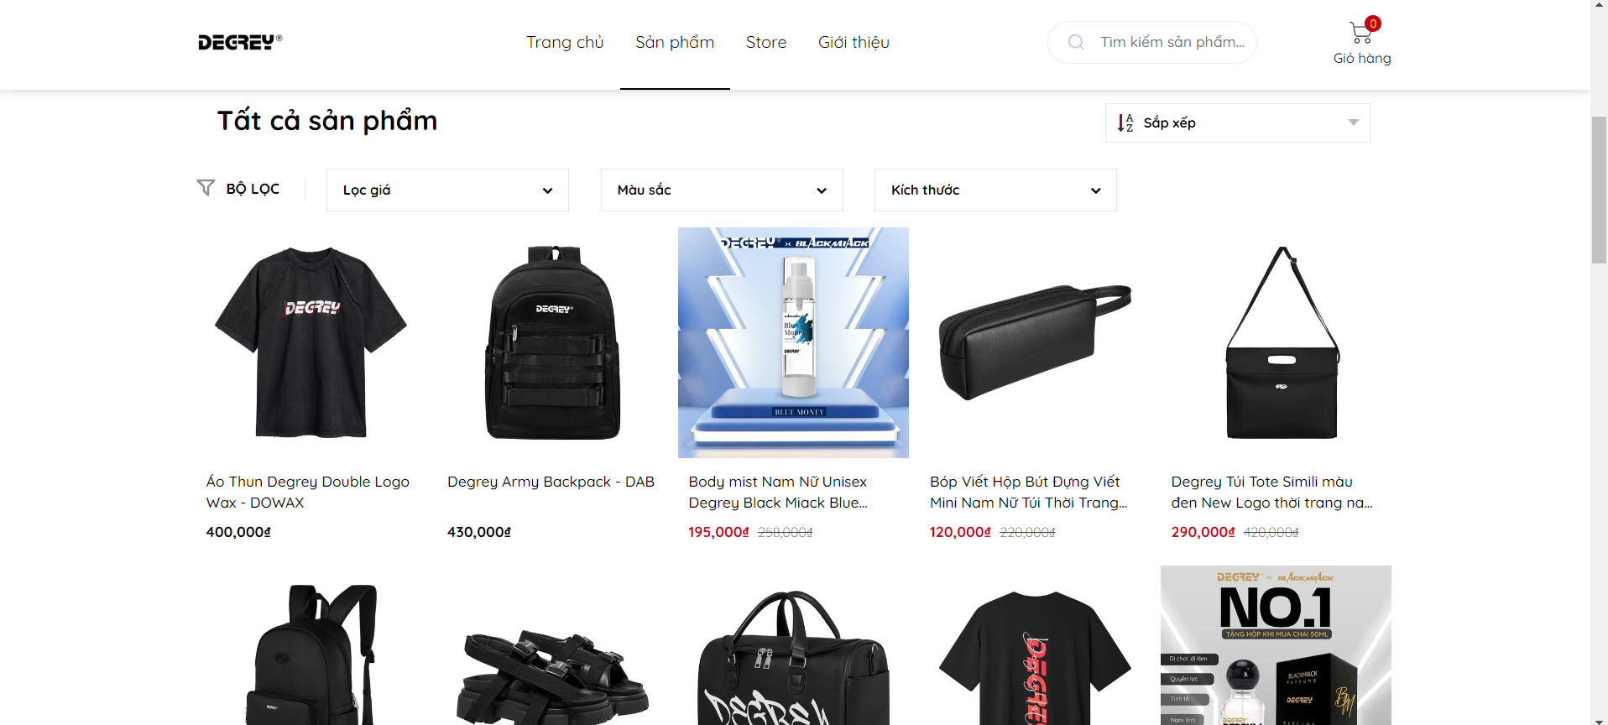

**Figure 1.1** Degrey website / Source: degrey.vn

Degrey is a garment brand founded in 2016 and is known and welcomed by many young people through its traditional products and shirt designs. The website has a user-friendly interface, easy to use, ... However, the website has a few limitations such as:

* The homepage interface is still sketchy and does not stand out much.
* There is no login or account registration function for users.
* Users cannot view the history of purchased orders.
* The user does not have a wishlist to save products they like for their next purchase.

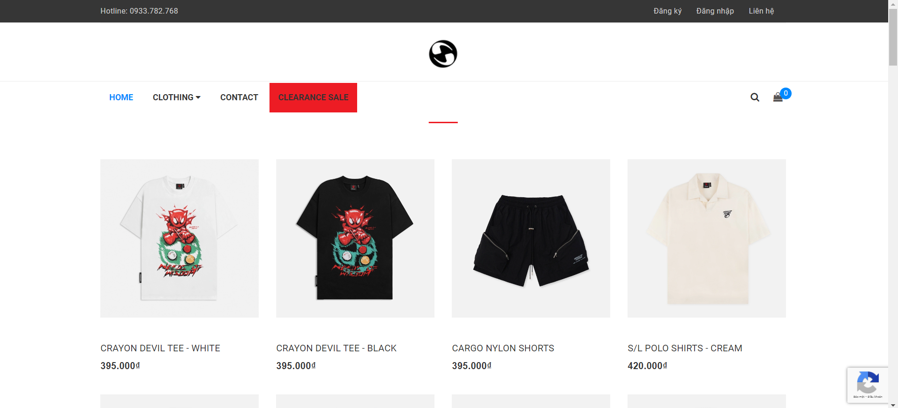

**Figure 1.2** Nowsaigon website / Source: nowsaigon.vn

Nowsaigon (NOW – Need of Wisdom) is a garment brand established in 2015, one of the first streetwear clothing brands in Vietnam.

Nowsaigon's website has a login and account registration function for users, but Nowsaigon's interface is not good with an unfriendly, unattractive interface, making the user experience unsatisfactory.

The two websites mentioned above are both owned by major brands in the streetwear apparel industry, and each website has its own advantages and disadvantages. After synthesizing the pros and cons, I want to try my best at design and move on to "Building Degrey website". In addition to overcoming disadvantages and adding advantages, the website must ensure all the functions of a sales website such as: ordering function, adding products to cart, searching for products, and processing orders, ...

### **Problem Solving**

Based on the descriptions of the above problems, I have searched for more information and researched appropriate technologies to come up with solutions to the following problems:

1. Apply User Centered Design Canvas to get a user overview of the website's purpose, scale and future development direction of the website application. This is the basic step in user experience design (UX Design).
2. Develop interface standards for the application so that the application is standardized in terms of color codes, fonts, font sizes, images of the website, etc. to create a uniform, impressive frame. entire website, avoiding a messy, unprofessional website interface, creating a bad user experience.
3. Develop detailed user interface design (UI Design) with interfaces: Login, registration, homepage, products, product details, stores, brand introduction, shopping cart...
4. Build a database with main components:
   * List of user and administrator information.
   * List of products by category.
   * List of product categories.
   * List color, size by product.
   * List of orders, order details.
   * User's shopping cart, wishlist.
   * List of order history by user
5. Build the Front-end interface according to UI design with the above standards corresponding or similar.
6. Build a Back-end system with the output product being a website with functions that can be used directly, solving the problems raised in the problem description.

## Technology Used

### **Figma design tool**

### 1.2.1.1 What is Figma?



**Figure 1.3** Figma design tool

**Figma** is a web-based user interface design tool that allows designers to create user interface designs and prototypes for websites or applications. Figma is a powerful and flexible tool used to create everything from simple drawings to complex interactive prototypes.

**Figma** has a number of features, which can also be called advantages, that make Figma a popular choice for designers:

* + Cloud Computing: Figma is web-based, which means Figma can be accessed from any web browser.
  + Strong and flexible: Figma has many powerful features that make it ideal for creating complex user interface designs.
  + Easy to use: Figma is relatively easy to use, even for those new to user interface design.
  + Free of charge: Figma has a free pack that includes many features.

### 1.2.1.2 Compare Figma with other tools

Among the popular applications used to design user interfaces, besides Figma, there are also Sketch and Adobe XD, which are the most widely used leading applications, introduced by publishers as software components. Specialized software for user interface design, instead of using graphic design software such as Adobe Photoshop, Adobe Illustrator, …

**Table 1.1** Table compare Figma with other tools

|  |  |  |  |
| --- | --- | --- | --- |
| **Criteria** | **Figma** | **Sketch** | **Adobe XD** |
| Free for personal or small groups | ✓ |  |  |
| Support platform: Window, LinuX, MacOS, Browser | ✓ | Just MacOS | Just Window and MacOS |
| Use when offline |  | ✓ | ✓ |
| Strong support community |  | ✓ | ✓ |
| Easy for beginners | ✓ |  |  |
| Prototyping | ✓ | ✓ | ✓ |
| Programmer support | ✓ | ✓ | ✓ |
| Working group | ✓ |  | ✓ |

With the above comparison criteria, I chose Figma as the user interface design tool for the website.

### **SQL Server Database**

### 1.2.2.1 What is SQL Server database?



**Figure 1.4** SQL Sever database

**SQL Sever**, or **Microsoft SQL Sever**, is a database management system developed by Microsoft. It is a software used to store, retrieve, and analyze data. SQL Sever is widely used in many different industries, including:

* + Enterprise: SQL Server is used to store customer data, orders, products, and other business data.
  + Government: SQL Server is used to store data about citizens, taxes, public services, and other government data.
  + Medical: SQL Server is used to store patient data, medical records, test results, and other medical data.
  + Education: SQL Server is used to store student data, scores, class schedules, and other educational data.

**SQL Server** has several key features:

* + High performance: SQL Server is designed to process data queries quickly and efficiently.
  + Scalability: SQL Server can be scaled to support large amounts of data and high numbers of users.
  + Security: SQL Server provides strong security features to protect data from unauthorized access.
  + Compatibility: SQL Server is compatible with many different programming languages ​​and operating systems.

### 1.2.2.2 Compare SQL Server, MySQL and Firebase

**Table 1.2** Compare SQL Sever with, MySQL, Firebase

|  |  |  |  |
| --- | --- | --- | --- |
| **Criteria** | **SQL Sever** | **MySQL** | **Firebase** |
| Database type | RDBMS relational database | RDBMS relational database | NoSQL databases store data as documents |
| Data model | Relational data model | Relational data model | Non-relational data model |
| Ability of extension | Vertically expandable | Vertically expandable. | Automatic horizontal scaling. |
| High performance | ✓ | ✓ | ✓ |
| Strong security | ✓ | ✓ | ✓ |
| Compatibility | ✓ | ✓ | ✓ |
| Price | There are copyright fees. | There is a free and paid version. | Free version with basic functions and paid version. |

With the above comparisons, we see that all three databases above are powerful tools, suitable for programmers. However, I will choose SQL Sever based on the time I have worked on this tool more than the other two tools.

### **Framework Bootstrap**

### 1.2.3.1 What is the Bootstrap framework?



**Figure 1.5** Boostrap Framework

**Boostrap** is a free, open-source front-end framework that helps create responsive web interfaces quickly and easily. This framework includes HTML, CSS and JavaScript, providing customizable UI and layout elements to create beautiful and mobile-friendly websites.

Some advantages of Bootstrap:

* + Easy to use: Bootstrap provides built-in UI and layout components, making it easy to create websites without writing a lot of code.
  + Responsive: Bootstrap automatically adjusts website interface to fit all screen sizes, from desktop to mobile.
  + Free and open source: Bootstrap is open source and free to use, helping you save costs and customize the framework according to your needs.
  + Large support community: Bootstrap has a large and active community, providing extensive support and documentation.

Some disadvantages of Bootstrap:

* + Difficult to customize: Bootstrap provides pre-built UI and layout components, customizing the interface can be difficult.
  + Difficult to create complex interfaces: Bootstrap is not suitable for creating complex web interfaces with many functions.
  + Increases page load capacity: Bootstrap uses JavaScript and CSS, using too much can increase page load capacity.

### 1.2.3.2 Compare Boostrap with other tools

**Table 1.3** Compare Boostrap, React nad Angular

|  |  |  |  |
| --- | --- | --- | --- |
| **Criteria** | **Boostrap** | **React** | **Angular** |
| Type | Framework CSS | Javascript Library | Javascript Framwork |
| Easy for beginner | ✓ |  |  |
| Efficiency | Medium | High | Medium |
| Easy customization |  | ✓ | ✓ |
| Suitable subject | Simple project, needs responsive | Single page web application | Large, complex web project |
| For beginners front-end DEV | ✓ |  |  |

With the above comparison criteria, React and Angular outperform Boostrap in terms of performance, customization, and audience scope. But React and Angular require users to have experience using this tool, so I chose **Boostrap** as the tool for Front-end programming for the project.

### **C# programming language and ASP.Net Core framework**

### 1.2.4.1 What is C# programming language?



**Figure 1.6** C# programming language

**C#** is a powerful, modern, object-oriented programming language developed by Microsoft. C# is an early part of Microsoft's .NET plan. C# is built on the foundation of the two most powerful languages, C++ and Java, and inherits many of their strengths.

Main features of **C#**:

* + OOP: C# helps programmers organize code into objects, making code easy to understand, maintain and reuse.
  + Static data types: C# helps detect errors early in the compilation process, making code more stable and secure.
  + High performance: C# is compiled into machine code, helping code run quickly and efficiently.
  + Cross-platform support: C# can run on many different operating systems such as Windows, Linux and macOS.
  + Large development community: C# has a large and active developer community, providing lots of resources and support.

**C#** is widely used in many fields, some applications of C#:

* + Windows software development: C# is the primary language for developing Windows applications with the .NET Framework.
  + Website development: C# can be used to develop web applications with ASP.NET.
  + Game development: C# is one of the most popular languages ​​for game development with Unity.
  + Mobile application development: C# can be used to develop mobile applications with Xamarin.
  + Systems programming: C# can be used to develop system applications such as Windows services.

**C#** is a modern, powerful and easy to learn programming language. **C#** has many applications in many fields and is in high demand in the labor market.

### 1.2.4.2 What is the ASP.Net Core framework?



**Figure 1.7**  Framework ASP.NET Core

**ASP.NET Core** is an open source, free, cross-platform framework developed by Microsoft to build modern web applications. It is the next version of ASP.NET, rewritten with many improvements and new features**.**

The main feature of ASP.Net Core is that it is open source and completely free to use, helping you save costs and customize the framework according to your needs. ASP.NET Core can run on many different operating systems such as Windows, Linux and macOS. It is also designed to be easily scalable, allowing you to develop large and complex web applications.

### 1.2.4.3 Compare ASP.Net Core with other frameworks

**Table 1.4** Compare ASP.NET Core with other frameworks

|  |  |  |  |  |
| --- | --- | --- | --- | --- |
| **Criteria** | **ASP.Net Core** | **Node.js (Express)** | **Python (Django)** | **Java (Spring boot)** |
| Type | Web framework, open source. | JavaScript framework for web building or API, open source. | Web framework, open source. | Web framework, open source. |
| Free price | ✓ | ✓ | ✓ | ✓ |
| Communication | .Net Core | JavaScript | Python | Java |
| Efficiency | High | High | Medium | High |
| For beginners | ✓ | ✓ | ✓ | ✓ |
| Application | Website, web application, web service. | Website, web application, API. | Websites, web applications. | Website, web application, API. |
| Strong support community | ✓ | ✓ | ✓ | ✓ |

With the above comparison criteria, I find that ASP.Net Core and Node.js are the two frameworks that beginners and people with little experience can most approach. Compared to the project's goals as well as the Node.js programming language, JavaScript, which I am not sure I can do best, I will choose **ASP.Net Core** for the Back-end system.

# : SERVEY AND ANALYZE SYSTEM DESIGN

## System survey

### **2.1.1 Survey user needs using the User Centered Design method**

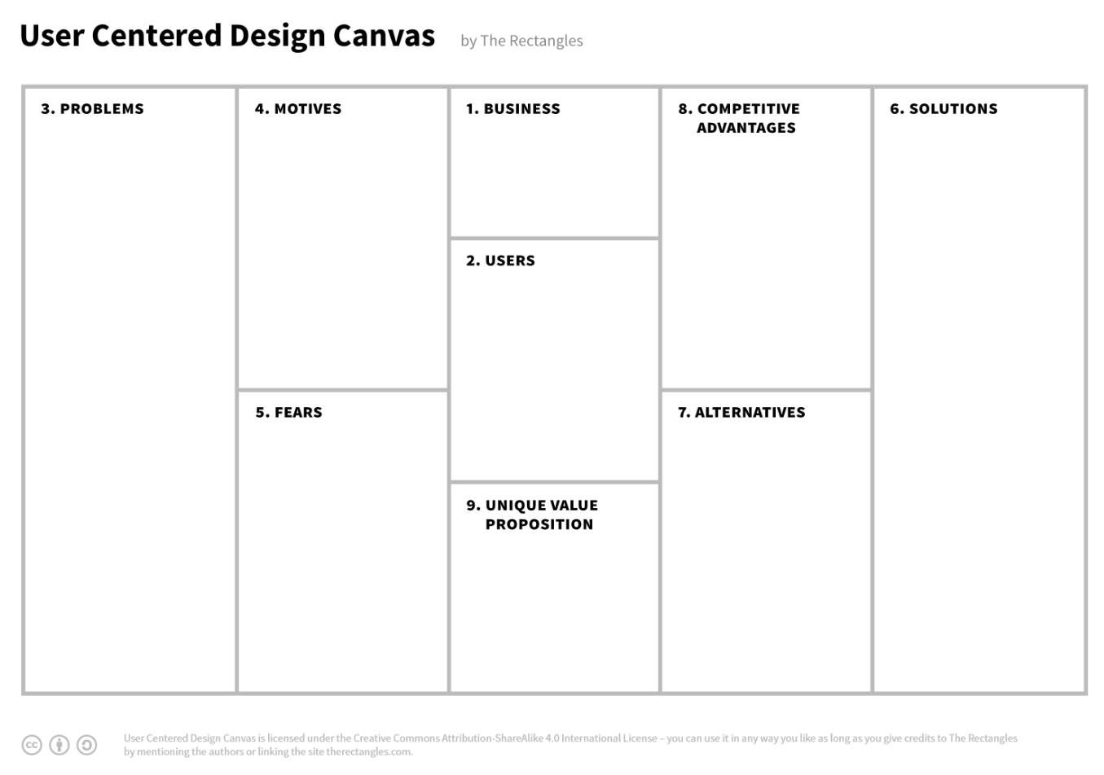

**Figure 2.1** User Center Design Convas / Source: thecanvasrevolution.com

User Centered Design (UCD) is a term formed from a series of analysis, statistics, planning, and data evaluation methods to outline a design model focused on user's key issues.

Depending on each project or product, the UCD process can be optimized to suit the goals of the product design and development team. However, the core factor is always the user.

The term UCD was formed in 1969. With a slightly longer name, it is User-Centerd System Design (UCSD), longer known as Human-Centerd System Design (HCSD). Based on the basic core values ​​in UCSD, people have begun to develop product design terms that are important and have a great influence on current perception. May be mentioned as:

* + Human-Centered Design (HCD)
  + User-Centerd Design (UCD)
  + User Experience (UX)
  + Inter-action Design (IxD) - The predecessor of today's term Interaction Design.
  + Human–Computer Interaction (HCI)
  + WIMP interfaces (Windows, Icons, Menus, Pointer)
  + Graphical User Interfaces (GUIs) -The predecessor of today's term User Interface (UI).

Depending on each industry, the above terms are optimized and applied logically to address the user's key factors.

The first step in the design process is to envision the user's needs and create an overview of how to address those needs. To solve this problem, I had Vietnameseized a very popular form in user experience design and researched and perfected this form, the results were as follows:

***Describe the problem:***

**Table 2.1** Problem in UCD form

|  |  |
| --- | --- |
| 1. **What is the customer's problem?** | * + Have a need to shop for streetwear garments.   + Need a website to be able to shop online at home.   + Currently, very few websites have eye-catching interfaces and are difficult to use. |
| 1. **The solution** | The website has an interface based on UI/UX design criteria, inspired by similar websites. |

***Customer description:***

**Table 2.2** Customer description in UCD form

|  |  |
| --- | --- |
| 1. **Who are the main customers?** | * + Young people who are interested in online shopping for domestic streetwear products (able to use computers and smart phones).   + Customer age: from 15-30 years old. |
| 1. **Who are the potential customers?** | Potential customers are men/women aged 15-25 who want to buy streetwear products. |
| 1. **What do customers worry about when using the product?** | * + Website is difficult to use, purchasing operations are complicated.   + Finding the right product takes a lot of time. |
| 1. **What is the customer's purpose when using the product?** | * + The website has a variety of product types and prices   + Easily track and look up shopping cart, wishlist, and order historys |

***Product Description:***

**Table 2.3** Product description in UCD form

|  |  |
| --- | --- |
| 1. **Main function solves the problem** | * + The website provides product search functionality by name, price, and product type.   + Provide wishlist, allowing customers toeasily order desired products for their next order.   + Provide order history lookup, helping customers make shopping plans and complain when encountering any problems related to the product.   + Provide online chat function to answer all customer questions about purchases, products, etc. |
| 1. **Differences from similar products** | Adding additional functions compared to similar websites: wishlist, search engine, order history... to improve customers' shopping experience. |
| 1. **Advertising and product support channels** | * + Facebook   + Tiktok   + Instagram |
| 1. **Where does product revenue come from?** | * + Sell ​​products.   + Develop additional customer levels with incentives and discount codes to stimulate users' purchasing ability. |
| 1. **How to determine the level of success of the product?** | * + Number of customers registering an account   + Order number of an account |

### **2.1.2 Surveys are available**

During the process of designing functions for the website, I examined useful surveys conducted from the **QandME** site, specifically as follows:

***Survey on fashion shopping habits of Vietnamese people***

*Participants*: Men/women aged 15-25 and over 25 years old - 512 participants.

This survey examines purchasing habits, as well as the differences between men and women.

*Survey summary:*

* + Female groups and people with income of 9 million or more are more interested in fashion...
  + 46% spend under 300k per month or less.
  + Price is the most important factor in making a purchasing decision, followed by design and quality.
  + 63% buy fashion online while the group selling fashion online is 14%.
  + Product diversity is the main reason why the above group of people buy online.

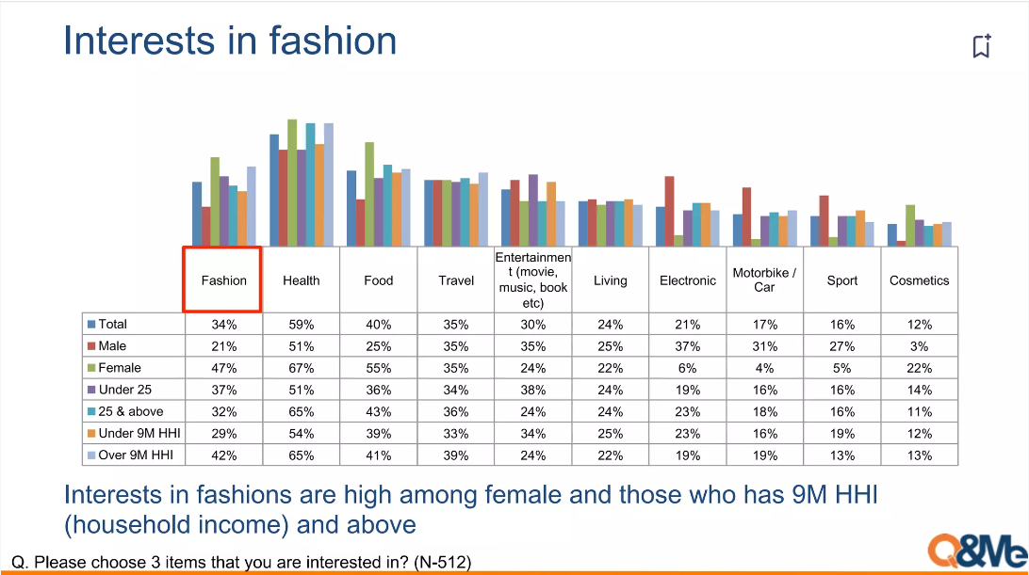

**Figure 2.2** Surveying the shopping habits of Vietnamese people today

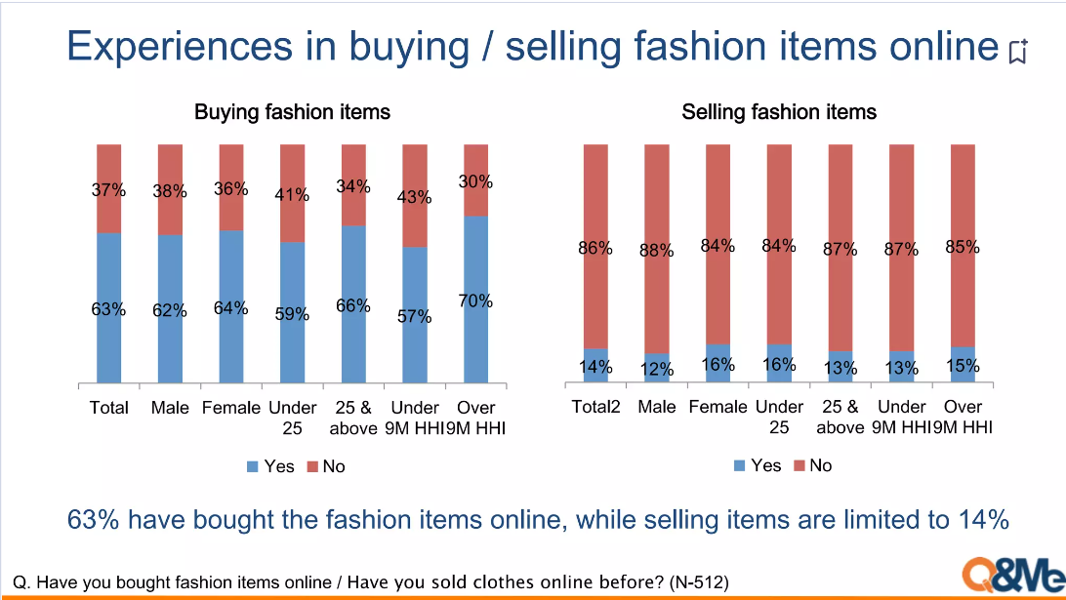

**Figure 2.3** Surveying on the experience of buying/selling fashion items online

## The expected features compared to similar websites

### **2.2.1 Similar websites**

Fashion brand NOWSAIGON (NOW - Needs of Wisdom) has been present in Ho Chi Minh City since 2015. Right from the first day of establishment, NOW has determined its own path by focusing on streetwear product lines.) with unique drawings, incorporating messages that spread positive energy to young people.

As one of the first streetwear brands in Vietnam, the NOW team designs, produces, and applies printing techniques to make products suitable for the style of Vietnamese youth. Like many other local brands, they encountered many difficulties and failures.

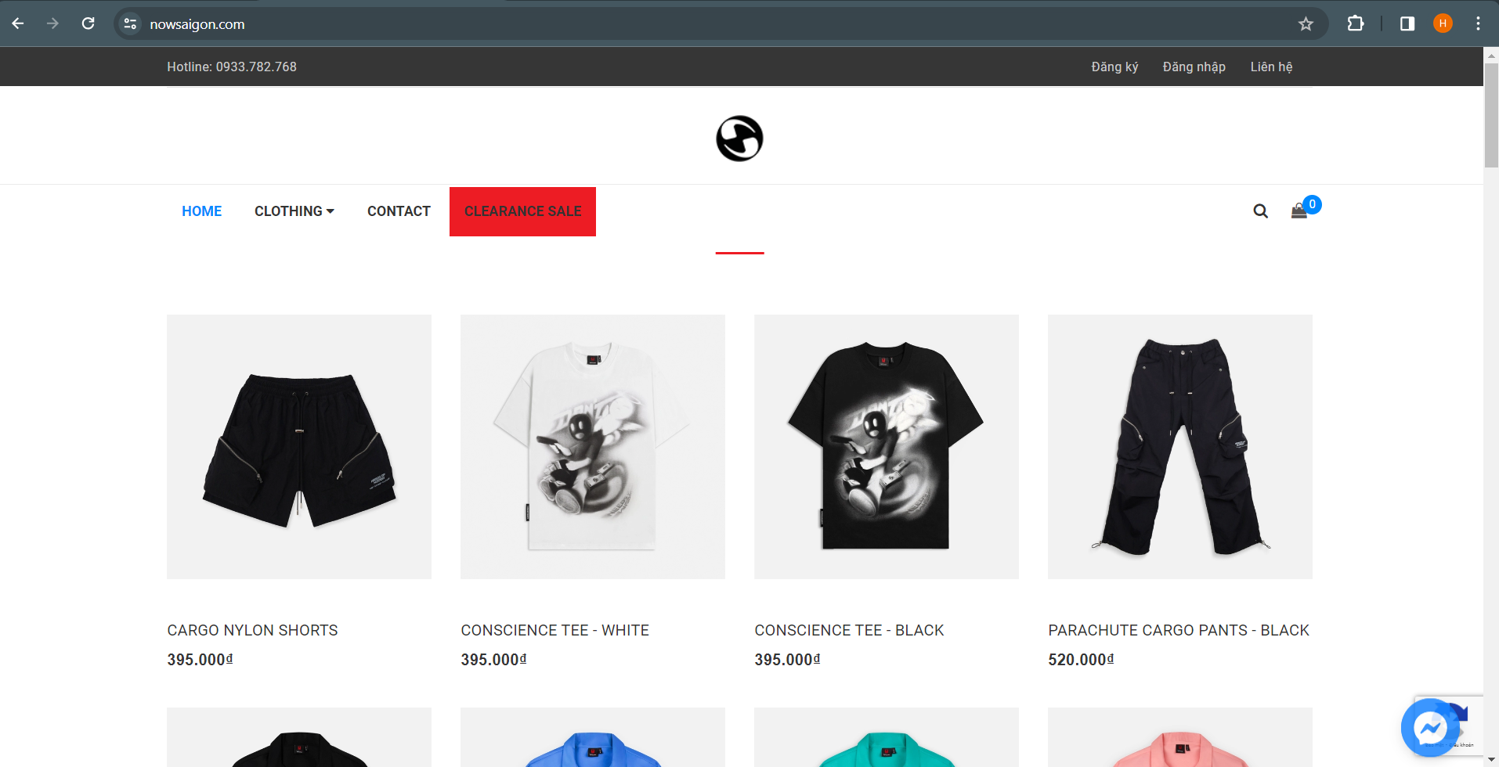

**Figure 2.4** NOWSAIGON / Source: nowsaigon.com

Established in 2016 and known to many young people through its media shirts, Degrey is currently gradually asserting its position on the Vietnamese streetwear map.

As a local brand with Asian trends, combining traditional and modern elements, Degrey always tries to bring meaningful cultural messages through each design line. Next, luxury and elegance are also the factors that create an attractive Degrey, the perfect choice for young people who love nostalgic style but still want to escape in newer outfits...

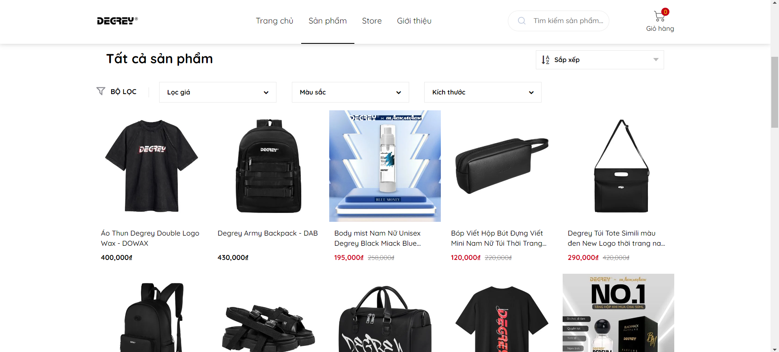

**Figure 2.5** DEGREY Viet Nam / Source: degrey.vn

With the slogan "Be the best of you", Karants wishes to bring beauty to everyone and contribute to creating a new - strange - beautiful image for Vietnamese fashion. Karants has focused on investing in quality. Product quality and design match the price so that the KARANTS brand is always your best choice.

KARANTS wants to bring customers the best products so that they not only express their personality but also spread positive, strong energy to everyone around them.

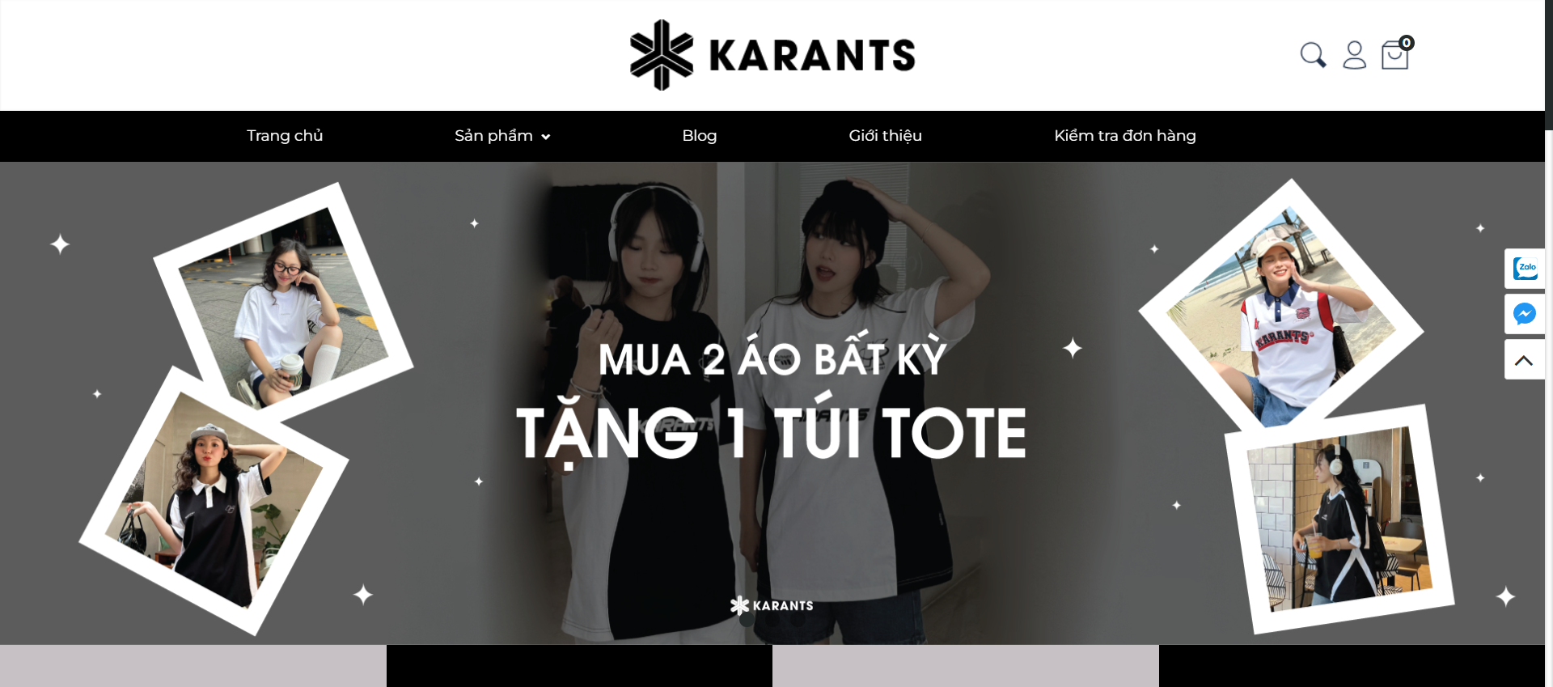

**Figure 2.6** KARANTS Viet Nam / Source: karants.vn

### **2.2.2 Compared features with similar websites**

**Table 2.4** Table comparing the project’s features with similar websites

|  |  |  |  |  |
| --- | --- | --- | --- | --- |
| **Criteria** | **My project** | **Degrey** | **Karants** | **Nowsaigon** |
| **User-friendly layout** | ✓ | ✓ | ✓ |  |
| **Balanced layout** | ✓ |  | ✓ |  |
| **Pagination** | ✓ |  | ✓ |  |
| **Login, register** | ✓ |  | ✓ | ✓ |
| **Product searching** | ✓ | ✓ | ✓ | ✓ |
| **Shopping and payment** | ✓ | ✓ | ✓ | ✓ |
| **Order history** | ✓ |  |  |  |
| **Wishlist products** | ✓ |  |  |  |
| **Check the shipping process** |  |  | ✓ |  |
| **Product types and products management** | ✓ | ✓ | ✓ | ✓ |
| **Order management** | ✓ | ✓ | ✓ | ✓ |
| **Ad sliders and banners management** | ✓ | ✓ | ✓ | ✓ |
| **Account management** | ✓ | ✓ | ✓ | ✓ |

**Details on product search differences:**

*Karants* and *Degrey* has search by product name and price filter... while *Nowsaigon* only have search by product name, the project is expected to have search by product name and price filter, product type.

* + 1. **Expected features of the project**

**Table 2.5** Project’s features

|  |  |  |
| --- | --- | --- |
| **No** | **Expected features** | **Request** |
| 1 | Layout | User-friendly layout, balanced layout, pagination. |
| 2 | Login, register | There is a login and registration form, users need to enter email information, password, full name, etc. |
| 3 | Product searching | There is a product search bar, product filtering by price and product type. |
| 4 | Shopping and payment | User adds products to cart, updates product quantity, then checks out. |
| 5 | Order history | Users can view a list of orders they have previously purchased. |
| 6 | Wishlist product | Users can add products to wishlist for convenience in their next purchase. |
| 7 | Product types and products management | Displayed in a list, administrators can add, edit, and delete information about product types or products. |
| 8 | Order management | Displayed in a list of orders, administrators can view details of orders that customers have placed, change order status, etc. |
| 9 | Account management | Displays a list of accounts, administrators can add, edit, delete account information, etc. |

## System description

### **2.3.1 Use Case Analysis**

Identify actors for the general Use-case diagram:

* + Guest
  + Cusomer
  + Manager

Identify the functions of each actor:

* + Guest:
* Register
* Search product
  + Customer:
* View order history
* Update shopping cart
* Payment orders
* Update wishlist
* Search product
* Log in
* Log out
  + Manager:
* Product updates
* Update product type
* Update order status
* View order detail
* Update account
* Log in
* Log out

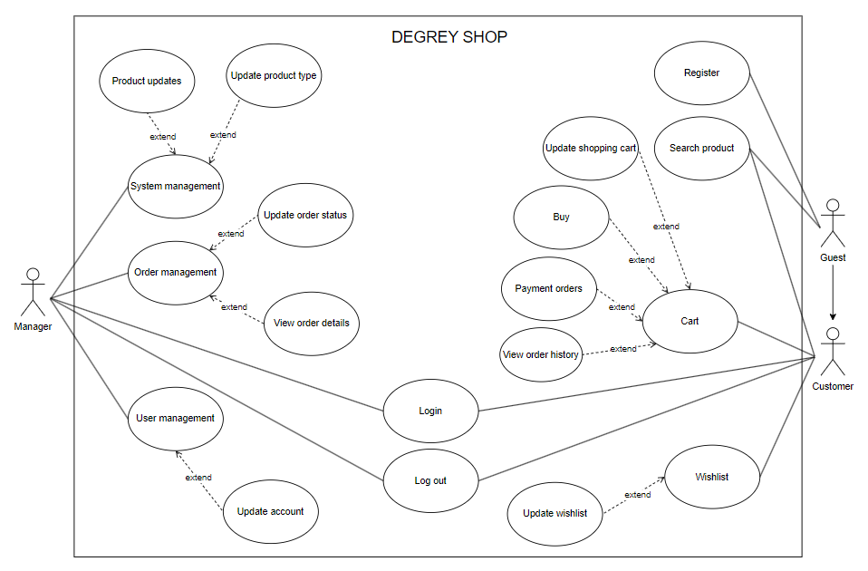

**Figure 2.7** General UC model

**Table 2.6** Detail description table of each use-case

|  |  |  |
| --- | --- | --- |
| **No** | **Use-case name** | **Description** |
| 1 | Product updates | Add, edit, delete, view product information, color, size |
| 2 | Update product type | Add, edit, delete, view product type information |
| 3 | Update order status | Change order status |
| 4 | View order details | View order details |
| 5 | Update account | Add, edit, delete, view account information |
| 6 | Update shopping cart | Add, delete, edit quantity, view products in cart |
| 7 | Buy | Purchase |
| 8 | Payment orders | Select a payment method |
| 9 | View order history | View history of purchased orders |
| 10 | Update wishlist | Add, delete, view products in wishlist |
| 11 | Log in | Allows customers and administrators to log in to the system |
| 12 | Log out | Allow customers and administrators to log out of the system |
| 13 | Register | Allow customers who do not have an account to register for a new account |

#### Login/register/log out

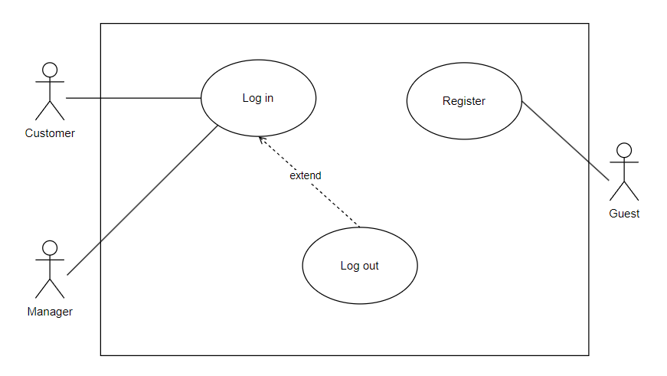

**Figure 2.8** UC login, logout, register

**Table 2.7** Detail description table of Login, logout, register use-case

|  |  |  |
| --- | --- | --- |
| **No** | **Use-case name** | **Description** |
| 1 | Log in | The administrator/customer logs into the system |
| 2 | Log out | The administrator/customer logs out and exits the system |
| 3 | Register | Customers who do not have an account can register for a new account |

#### Search product

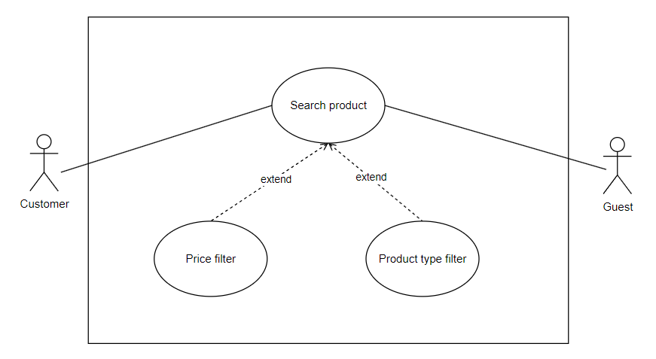

**Figure 2.9** UC product search

**Table 2.8** Detail description table of Product search use-case

|  |  |  |
| --- | --- | --- |
| **No** | **Use-case name** | **Description** |
| 1 | Search product | Customers/Unregistered customers can search for products on the menu bar |
| 2 | Price filter | Customers/Unregistered customers can search for products through price filters from low to high or vice versa |
| 3 | Product type filter | Customers/Unregistered customers can search for products through product categories |

#### Update shopping cart, wishlist, look up order history

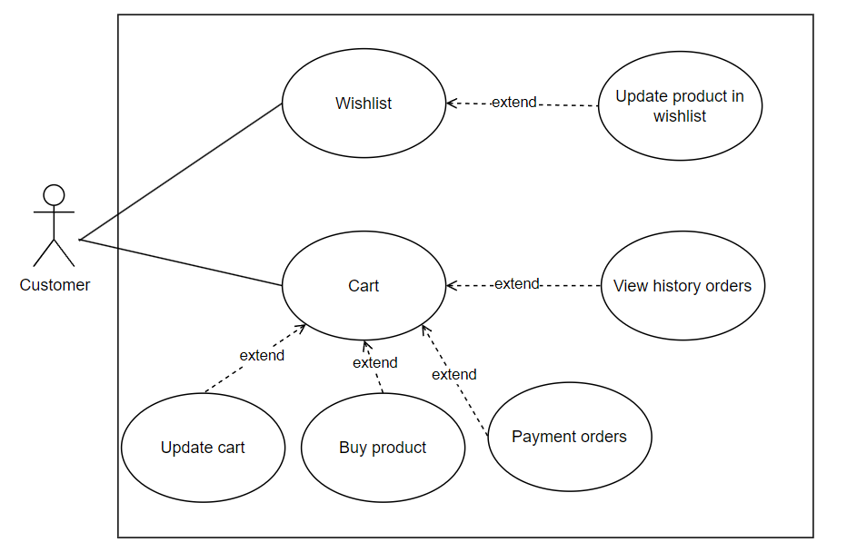

**Figure 2.10** UC to update shopping cart, wishlist, order history

**Table 2.9** Detail description table of shopping cart, wishlist, order history

|  |  |  |
| --- | --- | --- |
| **No** | **Use-case name** | **Description** |
| 1 | Cart | Customers can click on the cart to view information about added products |
| 2 | Update cart | Customers can change the quantity and delete products in the shopping cart |
| 3 | Buy product | The customer proceeds to purchase all products in the shopping cart |
| 4 | Payment orders | Customers can choose payment methods for orders |
| 5 | View history orders | Customers can view previously placed orders |
| 6 | Wishlist | Customers can click on the wishlist to view information about added products and save products for the next purchases |
| 7 | Update product in wishlist | Customers can delete products in wishlist |

#### Update account

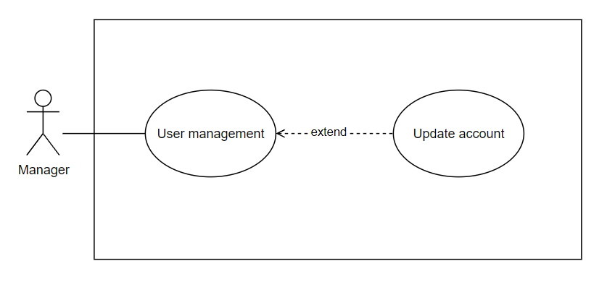

**Figure 2.11** UC update account

**Table 2.10** Detail description table of update account

|  |  |  |
| --- | --- | --- |
| **No** | **Use-case name** | **Description** |
| 1 | User management | Administrators can make account changes |
| 2 | Update account | Administrators can add, edit information or delete accounts |

#### Product updates

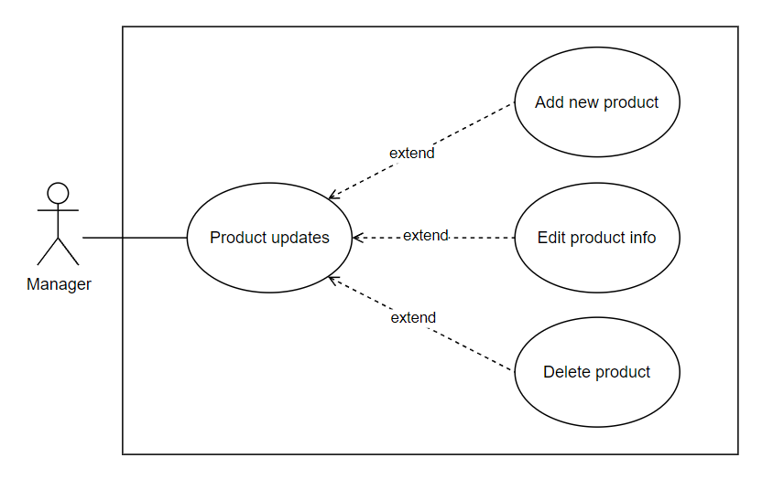

**Figure 2.12** UC products update

**Table 2.11** Detail description table of UC products update

|  |  |  |
| --- | --- | --- |
| **No** | **Use-case name** | **Description** |
| 1 | Product updates | Người quản trị có thể tạo các thay đổi về sản phẩm |
| 2 | Add new product | Người quản trị có thể tạo sản phẩm mới |
| 3 | Edit product info | Người quản trị có thể thay đổi thông tin sản phẩm |
| 4 | Delete product | Người quản trị có thể xóa sản phẩm |

#### Update product category

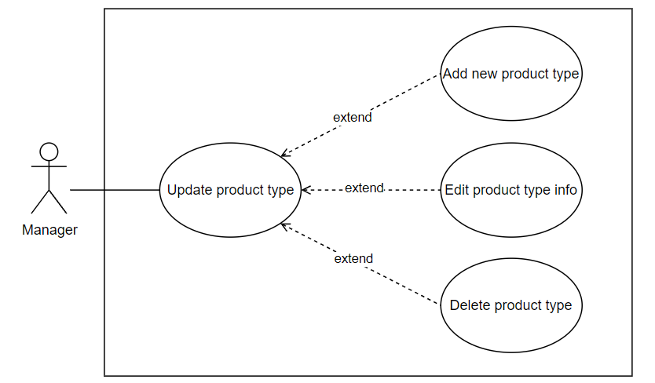

**Figure 2.13** UC update product categories

**Table 2.12** Detail description table of UC update product categories

|  |  |  |
| --- | --- | --- |
| **No** | **Use-case name** | **Description** |
| 1 | Update product type | Admins can make changes to product types |
| 2 | Add new product type | Admins can create new product types |
| 3 | Edit product type info | Administrators can change product type information |
| 4 | Delete product type | Admins can delete product types |

#### Process orders, look up order details

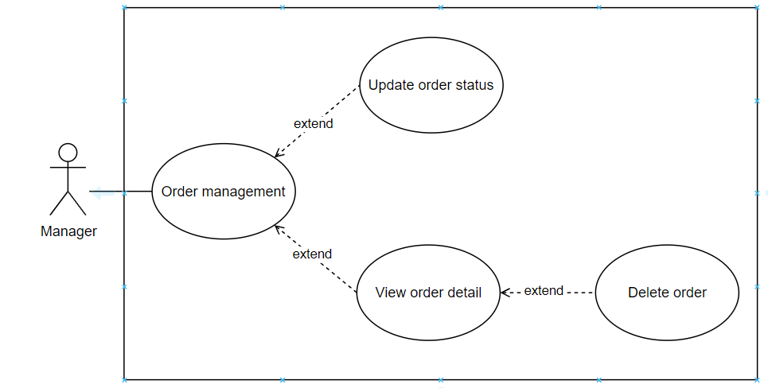

**Figure 2.14** UC orders process, order history

**Table 2.13** Detail description table of UC orders process, order history

|  |  |  |
| --- | --- | --- |
| **No** | **Use-case name** | **Description** |
| 1 | Order management | Admins can make changes to orders |
| 2 | Update order status | Admin can change order status |
| 3 | View order detail | Admin can view order details |
| 4 | Delete order | Admin can delete orders |

### **2.3.2 Sequence diagram**

#### 2.3.2.1 Order

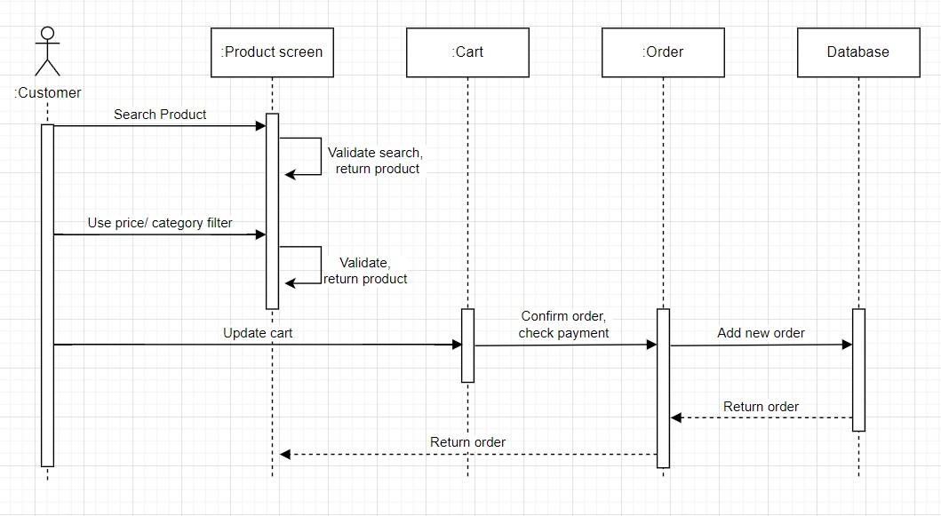

**Figure 2.15** Order sequence diagram

#### 2.3.2.2 Add new products/product categories

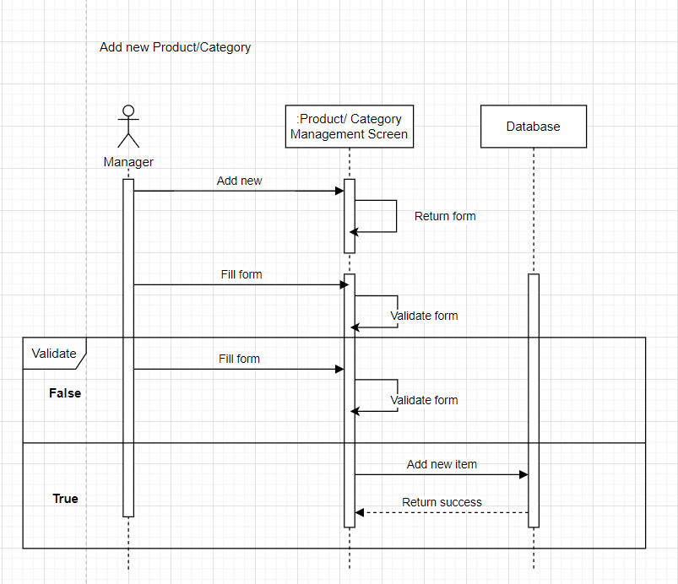

**Figure 2.16** Add new Products/Categories Sequence Diagram

#### 2.3.2.3 Order payment

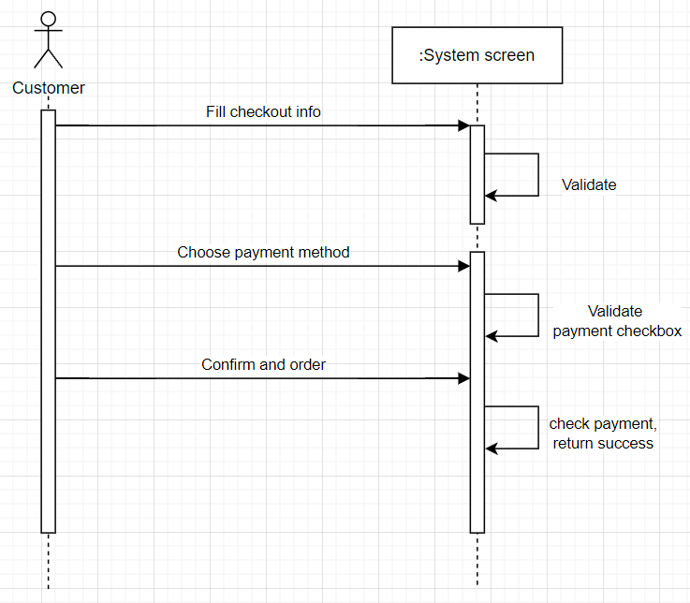

**Figure 2.17** Order’s payment sequence diagram

### **2.3.3 Database design**

#### 2.3.3.1 Database table

**Table 2.14** Database table

|  |  |  |
| --- | --- | --- |
| **No** | **Table name** | **Description** |
| 1 | Users | Stores user information such as name, email, address, phone number, and password. |
| 2 | Categories | Stores information about product categories.  Helps classify products into different categories. |
| 3 | Color | Stores information about product colors including color names, color codes and images.  Link to the Products table to define colors for each product. |
| 4 | Size | Stores information about product sizes.  Link to the Products table to determine the size for each product. |
| 5 | Products | Stores information about products such as name, description, discounts, photos, prices, and notes.  Link to the Categories table to determine the product's category. |
| 6 | Orders | Stores information about orders such as status, total value, discounts, creation date, shipping address, and notes.  Link to the Users and Discount tables to determine the orderer and the applicable discount program. |
| 7 | Order\_Detail | Store detailed information about the products in each order such as status, total value, discount, creation date, delivery address, color and size.  Link to the Orders and Discount tables to determine orders and discounts applied to each product in the order. |
| 8 | Payment | Stores information about payments such as name, status, payment date. |
| 9 | Discount | Stores information about sales such as name, discount percentage, description, end date, status, and photo.  Use to apply discounts to orders. |
| 10 | Rating | Stores user review information about products such as number of review stars, comments, and review date.  Link to the Products and Users tables to identify products and users performing reviews. |
| 11 | City | Stores information about cities such as city codes and city names.  Used to manage user address information and shipping addresses. |
| 12 | District | Stores information about districts such as name, district code and links to the City table to determine the city of that district. |
| 13 | Ward | Store information about wards/communes such as name, ward/commune code, and link with the City and District table to identify the city and district of that ward/commune. |

#### 2.3.3.2 Table description

**Table 2.15** Users table

|  |  |  |  |  |
| --- | --- | --- | --- | --- |
| **No** | **Data field name** | **Datatypes** | **Description** | **Note** |
| 1 | Id\_User | Int | User id | Auto increase  Primary Key |
| 2 | Name | Nvarchar(500) | Username |  |
| 3 | Email | Nvarchar(500) | User email |  |
| 4 | Address | Nvarchar(MAX) | User address |  |
| 5 | Phone | Int | User phone number |  |
| 6 | Password | Nvarchar(500) | User password |  |

**Table 2.16** Products table

|  |  |  |  |  |
| --- | --- | --- | --- | --- |
| **No** | **Data field name** | **Datatypes** | **Description** | **Note** |
| 1 | Id\_Product | Int | Product id | Auto increase  Primary Key |
| 2 | Name | Nvarchar(4000) | Product name |  |
| 3 | Description | Nvarchar(4000) | Product description |  |
| 4 | Note | Nvarchar(max) | Product note |  |
| 5 | Photo | Nvarchar(4000) | Product photo |  |
| 6 | Price | Float | Product price |  |
| 7 | Discount | Nvarchar(4000) | Product discount |  |
| 8 | fk\_Id\_Category | int | Category id | Foreign Key |

**Table 2.17** Categories table

|  |  |  |  |  |
| --- | --- | --- | --- | --- |
| **No** | **Data field name** | **Datatypes** | **Description** | **Note** |
| 1 | Id\_Category | Int | Category id | Auto increase  Primary Key |
| 2 | Name | Nvarchar(500) | Category name |  |

**Table 2.18** Color table

|  |  |  |  |  |
| --- | --- | --- | --- | --- |
| **No** | **Data field name** | **Datatypes** | **Description** | **Note** |
| 1 | Id\_Color | Int | Color id | Auto increase  Primary Key |
| 2 | Name | Nvarchar(500) | Color name |  |
| 3 | Color\_Code | Nvarchar(500) | Color code |  |
| 4 | Photo | Nvarchar(500) | Product color photo |  |
| 5 | fk\_Id\_Product | int | Product id | Foreign Key |

**Table 2.19** Size table

|  |  |  |  |  |
| --- | --- | --- | --- | --- |
| **No** | **Data field name** | **Datatypes** | **Description** | **Note** |
| 1 | Id\_Size | Int | Category id | Auto increase  Primary Key |
| 2 | Name | Nvarchar(500) | Category name |  |
| 3 | fk\_Id\_Product | int | Product id | Foreign Key |

**Table 2.20** Orders table

|  |  |  |  |  |
| --- | --- | --- | --- | --- |
| **No** | **Data field name** | **Datatypes** | **Description** | **Note** |
| 1 | Id\_Order | Int | Order id | Auto increase  Primary Key |
| 2 | fk\_Id\_User | Int | User id | Foreign Key |
| 3 | fk\_Id\_Discount | int | Discount id | Foreign Key |
| 4 | CreateDate | Date | Order create date |  |
| 5 | Total\_Price | Float | Total price |  |
| 6 | Status | Int | Order status |  |
| 7 | Payment | int | Payment |  |
| 8 | Address | Nvarchar(500) | Delivery address |  |
| 9 | Note | Nvarchar(500) | Note |  |

**Table 2.21** Order\_Detail table

|  |  |  |  |  |
| --- | --- | --- | --- | --- |
| **No** | **Data field name** | **Datatypes** | **Description** | **Note** |
| 1 | Id\_OrderDetail | Int | Order detail id | Auto increase  Primary Key |
| 2 | fk\_Id\_Order | Int | Order id | Foreign Key |
| 3 | fk\_Id\_Product | Int | Product id | Foreign Key |
| 4 | Quantity | Int | Quantity |  |
| 5 | Price | Float | Total price |  |
| 6 | Color | Nvarchar(50) | Color by product |  |
| 7 | Size | Nvarchar(50) | Size by product |  |

**Table 2.22** Discount table

|  |  |  |  |  |
| --- | --- | --- | --- | --- |
| **No** | **Data field name** | **Datatypes** | **Description** | **Note** |
| 1 | Id\_Discount | Int | Discount id | Auto increase  Primary Key |
| 2 | Name | Nvarchar(500) | Discount code |  |
| 3 | Percent | Float | Discount percent |  |
| 4 | Description | Nvarchar(500) | Discount description |  |
| 5 | End\_Date | Date | Discount end date |  |
| 6 | Status | Int | Discount status |  |
| 7 | Photo | Nvarchar(MAX) | Photo |  |

**Table 2.23** Payment table

|  |  |  |  |  |
| --- | --- | --- | --- | --- |
| **No** | **Data field name** | **Datatypes** | **Description** | **Note** |
| 1 | Id\_Payment | Int | Payment id | Auto increase  Primary Key |
| 2 | Name | Nvarchar(500) | Payment name |  |
| 3 | Status | Int | Payment status |  |
| 4 | Paid\_date | Date | Payment paid date |  |
| 5 | fk\_Id\_Order | int | Order id | Foreign Key |

**Table 2.24** Rating table

|  |  |  |  |  |
| --- | --- | --- | --- | --- |
| **No** | **Data field name** | **Datatypes** | **Description** | **Note** |
| 1 | Id\_Rate | Int | Rate id | Auto increase  Primary Key |
| 2 | fk\_Id\_User | Int | User id | Foreign Key |
| 3 | fk\_Id\_Product | Int | Product id | Foreign Key |
| 4 | Rating | Int | Rating score |  |
| 5 | Comment | Nvarchar(50) | User comment |  |
| 6 | Rate\_Date | date | Rate date |  |

**Table 2.25** City table

|  |  |  |  |  |
| --- | --- | --- | --- | --- |
| **No** | **Data field name** | **Datatypes** | **Description** | **Note** |
| 1 | Id\_City | Int | City id | Auto increase  Primary Key |
| 2 | Name | Nvarchar(500) | City name |  |
| 3 | City\_Code | Nvarchar(500) | Abbreviate the city name |  |

**Table 2.26** Disctrict table

|  |  |  |  |  |
| --- | --- | --- | --- | --- |
| **No** | **Data field name** | **Datatypes** | **Description** | **Note** |
| 1 | Id\_District | Int | District id | Auto increase  Primary Key |
| 2 | Name | Nvarchar(500) | District name |  |
| 3 | District\_Code | Nvarchar(500) | Abbreviate the district name |  |
| 4 | fk\_City\_Id | int | City id | Foreign Key |

**Table 2.27** Ward table

|  |  |  |  |  |
| --- | --- | --- | --- | --- |
| **No** | **Data field name** | **Datatypes** | **Description** | **Note** |
| 1 | Id | Int | Ward id | Auto increase  Primary Key |
| 2 | Name | Nvarchar(500) | Ward name |  |
| 3 | Ward\_Code | Nvarchar(500) | Abbreviate the ward name |  |
| 4 | fk\_City\_Id | int | City id | Foreign Key |
| 5 | fk\_District\_Id | int | District id | Foreign Key |

#### 2.3.3.3 Relational model

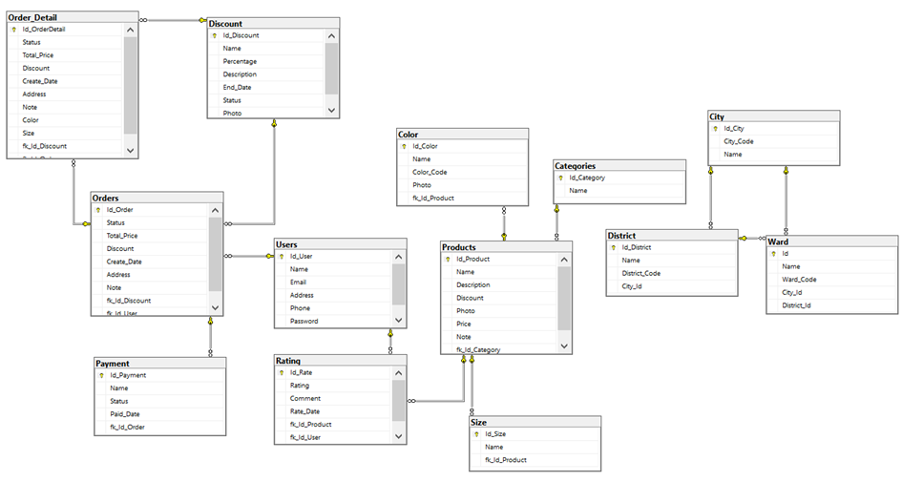

**Figure 2.18** Relational model

# : BUILD THE PROGRAM

## System interface design

The interface uses the main colors: #FFFFFF, #000000, #B9B9B9

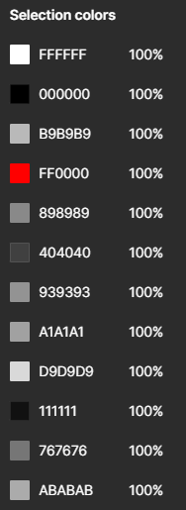

**Figure 3.1** Main color used

### **Homepage Interface**

Homepages interface include:

* + Header bar includes email shop, login, registration
  + Logo, Menu bar, Search, Wishlist, Shopping Cart
  + Auto slider
  + Advertise your collection
  + Recommended products
  + Discounted products
  + Footer

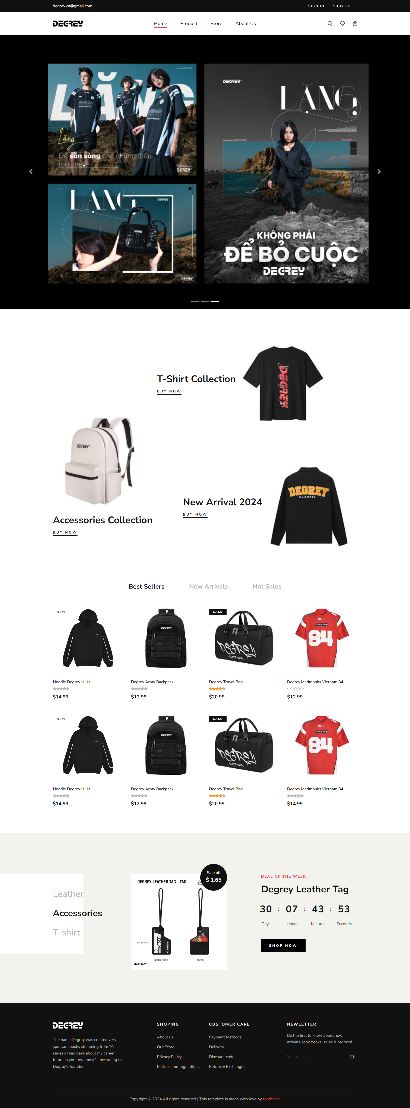

**Figure 3.2** Homepage interface

### **Shop Interface (Products)**

Shop interface include:

* + Headerbar, Menu bar, Footer is like the Homepage Module
  + Breadcrumb
  + Sidebar includes Search, filter by Category, filter by product price range, product color, product size
  + The product section is paged and filtered by price from low to high and vice versa

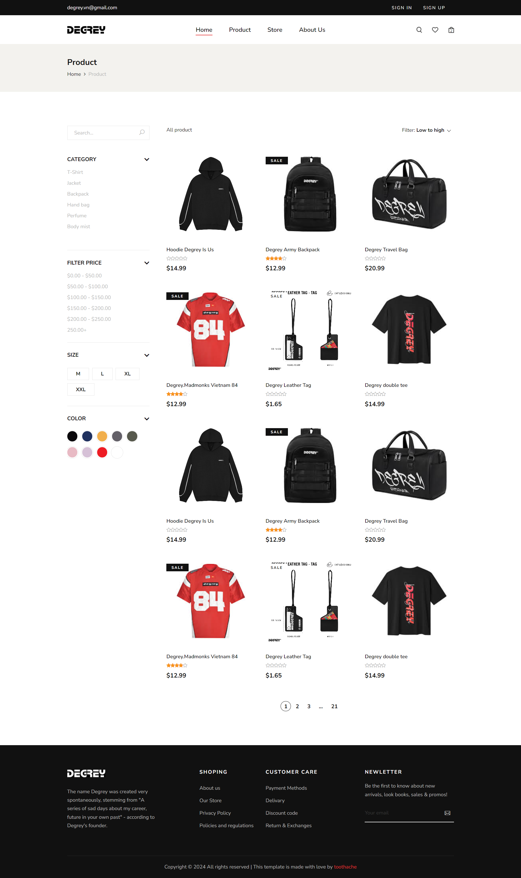

**Figure 3.3** Shop (Products) interface

### **Product Detail Interface**

Product detail include:

* + Headerbar, Menu bar, Footer is like the Homepage Module
  + Breadcrumb, product photo
  + Product information section (name, price, choose size, color), quantity, add to cart
  + Section selects to view product description and product reviews
  + Similar product sections

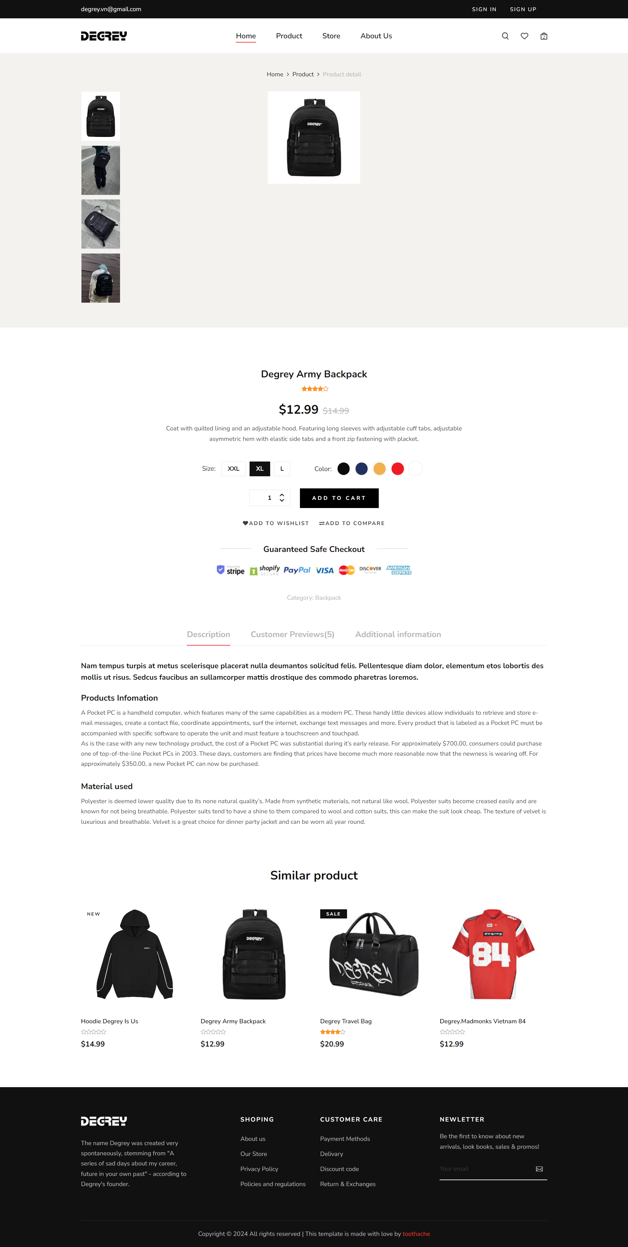

**Figure 3.4** Product detail interface

### **Shopping Cart Interface**

Shopping carts include:

* + Headerbar, Menu bar, Footer are like the Homepage Module
  + Breadcrumb
  + Product information display board
  + Sidebar displays discount code, payment information, payment button

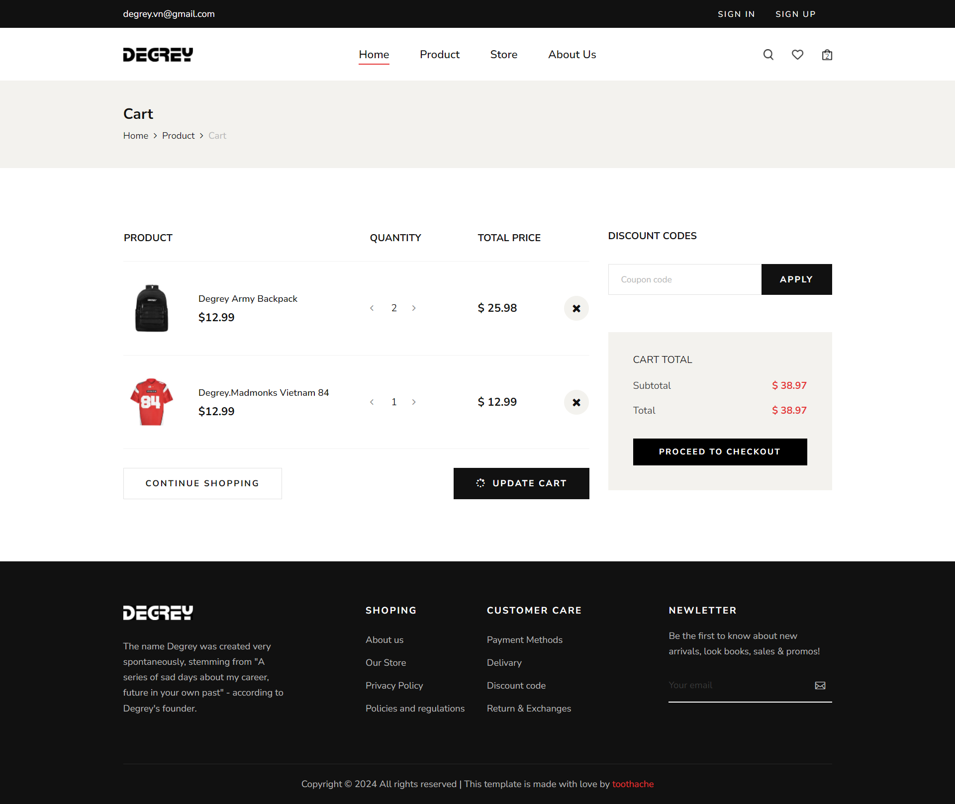

**Figure 3.5** Shopping cart interface

### **Checkout Interface**

Checkouts include:

* + Headerbar, Menu bar, Footer are like the Homepage Module
  + Breadcrumb
  + Table for entering customer information, delivery address, notes
  + Product information panel, total amount, choose payment method, order button

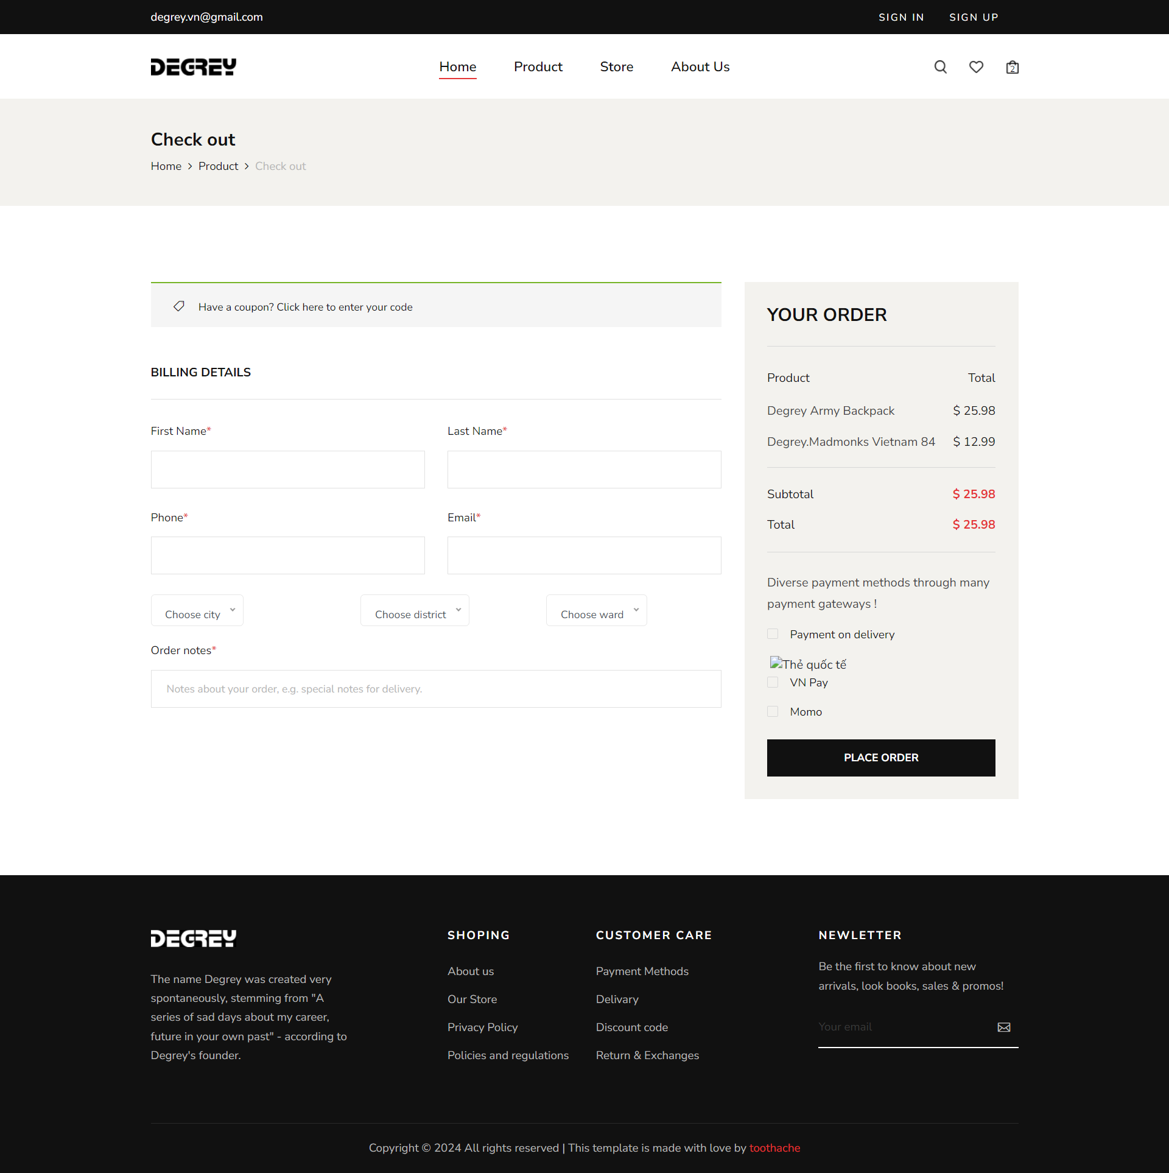

**Figure 3.6** Checkout interface

### **Store interface**

Store interface include:

* + Headerbar, Menu bar, Footer is similar to the Homepage Module
  + Google map address of the store
  + Information and store address
  + Send questions via email
  + Footer are similar to the Module Homepage

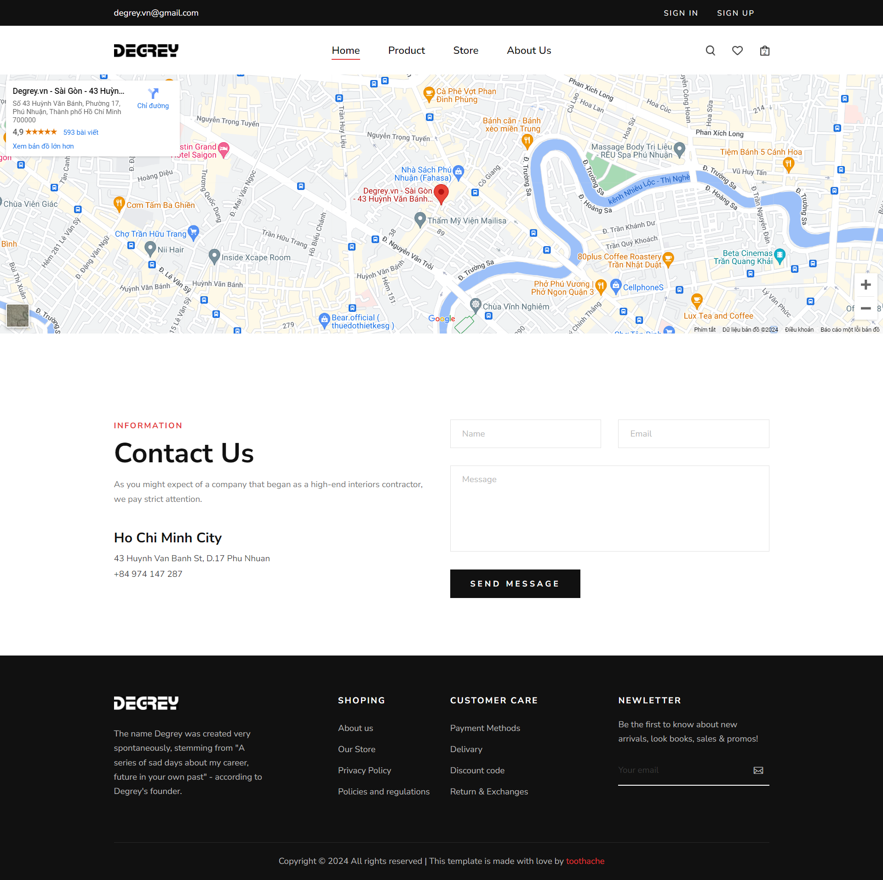

**Figure 3.7** Store interface

### **About Us Interface**

About us module include:

* + Headerbar, Menu bar, Footer are similar to the Homepage Module
  + Breadcrumb
  + Photos, brand introduction information, founder's message
  + Products in cooperation with other brands

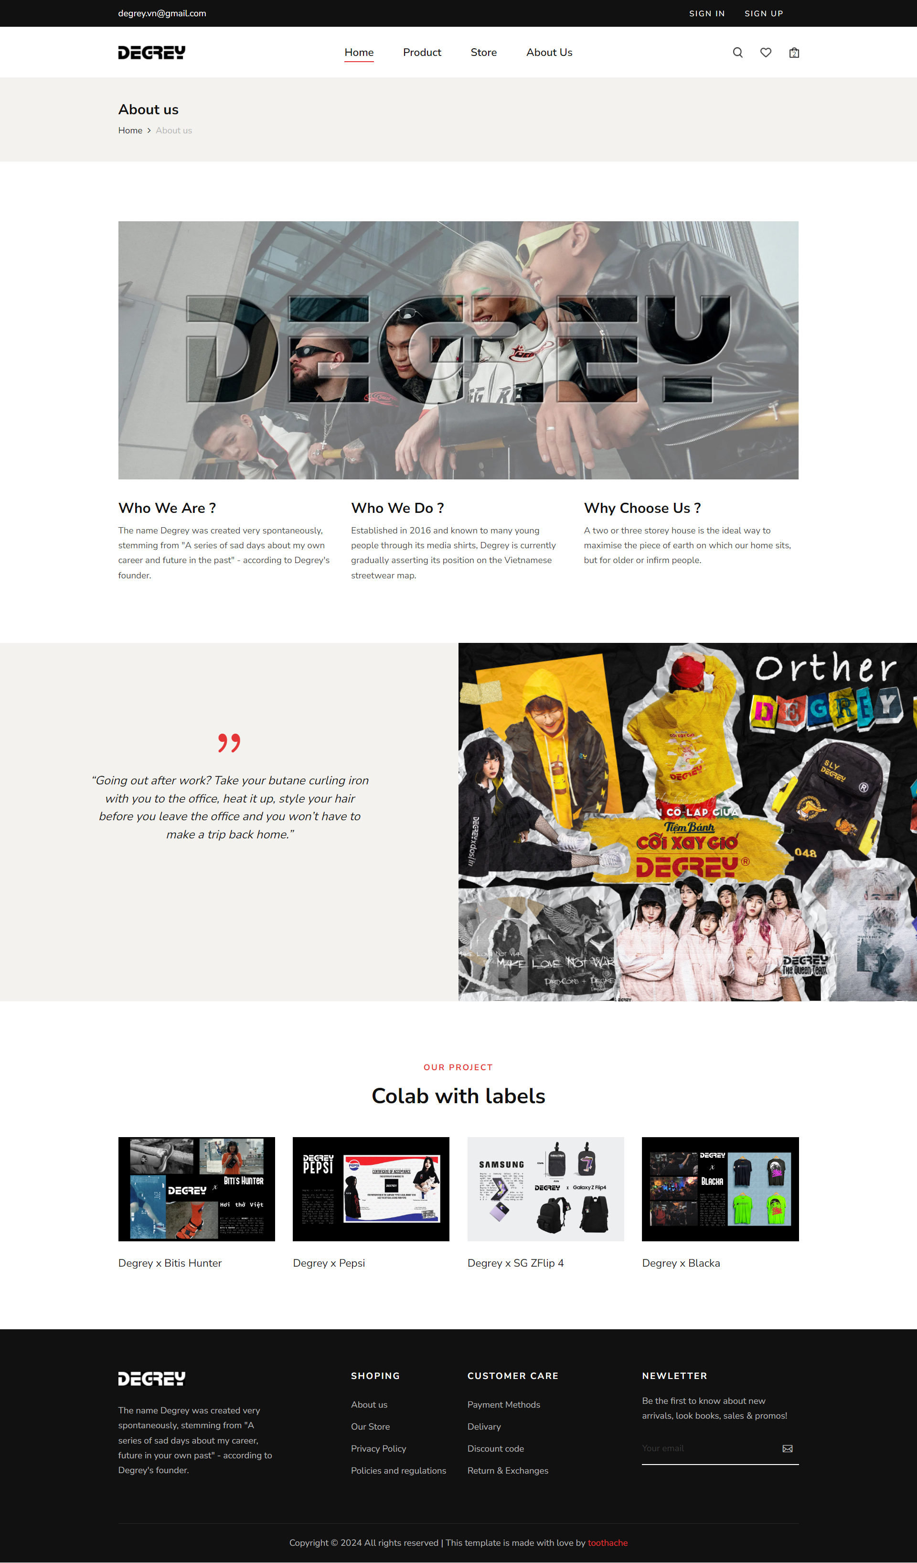

**Figure 3.8** About us interface

Figma project link: <https://www.figma.com/design/UYQojYKo39eVvyWUvSVQlJ/Degrey-shop?node-id=0-1&t=YcDRBa5NkDyqzLmQ-1>

## Install application

Initialize the project using the following technologies:

* + Template ASP.NET Core Empty with framwork .NET 7.0.
  + Microsoft SQL Sever Management Studio 18: Create a database to store the website's data.

To create my project, do the following steps:

* + Connect to the database via “appsetting.json”.

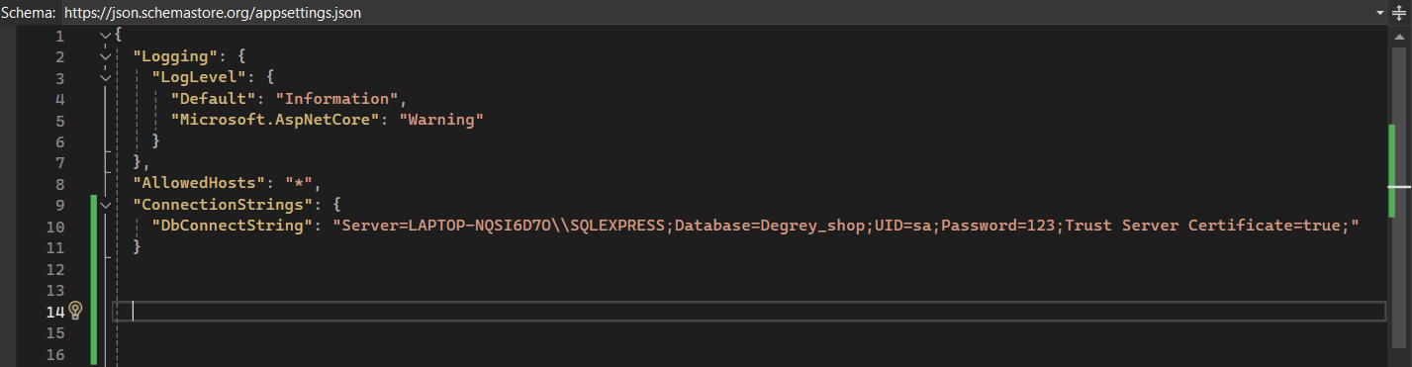

**Figure 3.9** appsettings.json

* + Create “Models” folder, it is used to contain model classes, represent the application's data, defining how the data is organized, processed, and interacted with the database and other parts of the application.

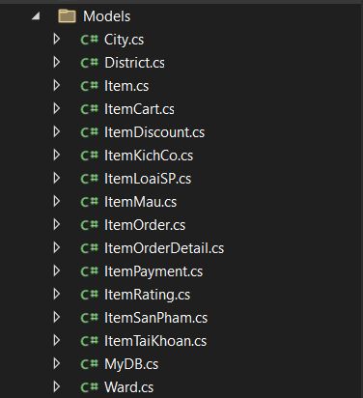

**Figure 3.10** Models folder

* + Create “MyDB” class, it is responsible for managing connections to the database and representing data in an ASP.NET Core application using Entity Framework Core.

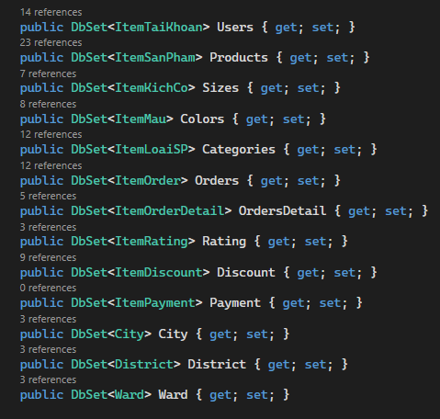

**Figure 3.11** MyDB class

### **Install Project Nuget Packages**

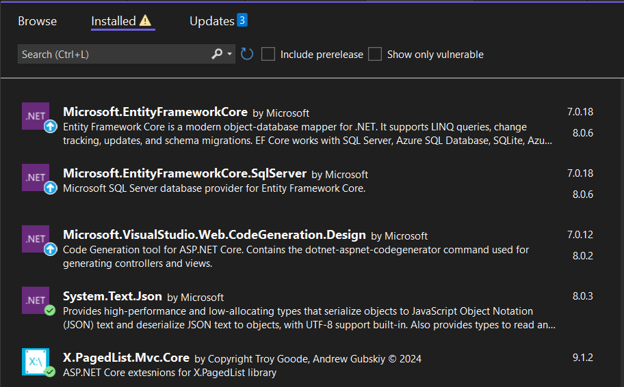

**Figure 3.12** Nuget packages

**Table 3.1** Nugets installed

|  |  |  |
| --- | --- | --- |
| **No** | **Name** | **Uses of Nuget** |
| 1 | Microsoft.EntityFrameworkCore | Used for integrating Entity Framework Core into .NET applications. EF Core is an Object-Relational Mapper that enables .NET developers to work with a database using .NET objects. |
| 2 | Microsoft.EntityFrameworkCore.SqlServer | Designed to enable Entity Framework Core to work with Microsoft SQL Server databases. |
| 3 | Microsoft.VisualStudio. Web.CodeGeneration.Design | Used to facilitate code generation in ASP.NET Core projects. |
| 4 | System.Text.Json | Used for handling JSON (JavaScript Object Notation) data in .NET applications. |
| 5 | X.PagedList.Mvc.Core | Used to implement pagination in ASP.NET Core MVC applications. |

### **The order placing feature as user**

The order placement functionality allows customers to add products to their shopping cart and proceed with their purchase.

Adding Items to the Cart:

* + When a customer browses through the available products, they have the option to add items to their shopping cart.
  + The system uses a method called “CartClass”, which is triggered when the customer clicks the "Add to Cart" button.
  + This method will add the product to the local browser and check if the product already exists; if it does, the quantity is existingQuantity + quantityToAdd.

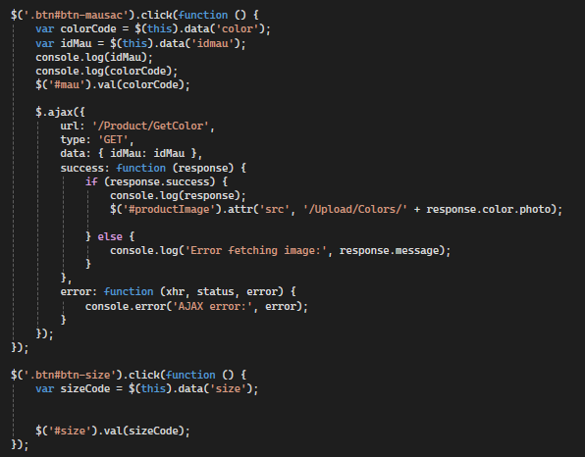

**Figure 3.13** Code when click choose color, change image product

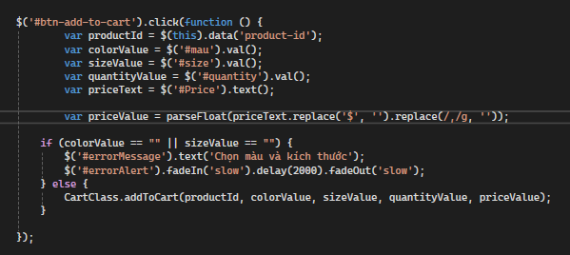

**Figure 3.14** Code add product to Cart

Add and remove products:

* + Add products: If the item is new or being added again, a new entry is created in the cart with details: product Id, name, quantity, color, size, image, and price.
  + Remove products: When click delete a product from the shopping cart, a notification will appear. When the user agrees to delete, the product will be removed from the cart.

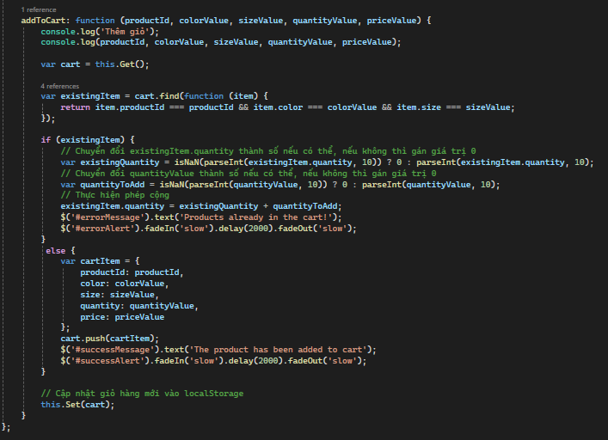

**Figure 3.15** Function addToCart in CartClass

Checkout is the final step in online shopping where customers complete their orders and proceed to make payment for the selected products. In this step, customers provide information about the shipping address, select the payment method, and review their order before finalizing the transaction.

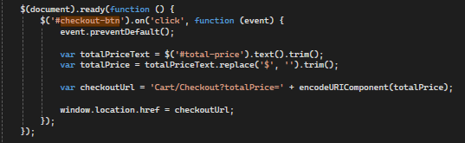

**Figure 3.16** Code event Checkout

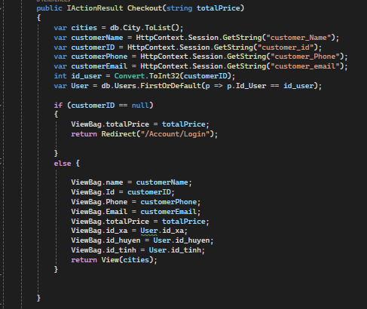

**Figure 3.17** Checkout Action

In this code, we first check if the customer is logged in. Then, we retrieve the product information from LocalStorage and update the necessary details such as the total amount and payment method. If the user is logged in, we fetch the information from the session to display the customer's details and proceed with the payment process. If the user is not logged in, we redirect them to the login page. Finally, we handle the payment process based on the selected payment method, which can be either VNPay or cash.

### **Order payment via VNPay**

VNPAY Wallet is a family e-wallet that allows users to create additional member wallets for their relatives. VNPAY Wallet features a diverse ecosystem of utilities that fully meet users' payment needs anytime, anywhere.



**Figure 3.18** VNPay Wallet

You can fully trust using the **VNPAY Wallet** because:

* + The security technology of VNPAY Wallet meets the strictest international standards in the banking and financial industry, achieving global security certification PCI DSS and international standard Blockchain technology.
  + Payment transactions require authentication using Password/Fingerprint/Face ID/Soft OTP.
  + Each of your transactions is encrypted and protected by VNPAY Wallet's system as soon as it is performed.

**VNPay Configuration on the Project**

To incorporate VNPay payment functionality into my website, you can utilize VNPay's APIs and SDKs, which provide developers with tools to integrate PayPal payments seamlessly.

* + Integration Setup: Configure my website to integrate with PayPal by setting up API credentials and payment settings. In the Api project, configure the VNPay the "appsettings.json" file.

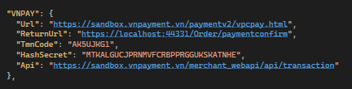

**Figure 3.19** VNPay Configuration in appsettings.json

* + Checkout Process: Implement a checkout process on your website where users can review their order and choose VNPay as their payment method.
  + Payment Process: Implement the payment process on your website, where users can review their orders and select VNPay as the payment method.
  + Redirect to VNPay: When users select VNPay as the payment option and click place order, redirect them to the VNPay website or initiate the contextual payment experience, where users can use QR codes or bank cards to complete their payment.

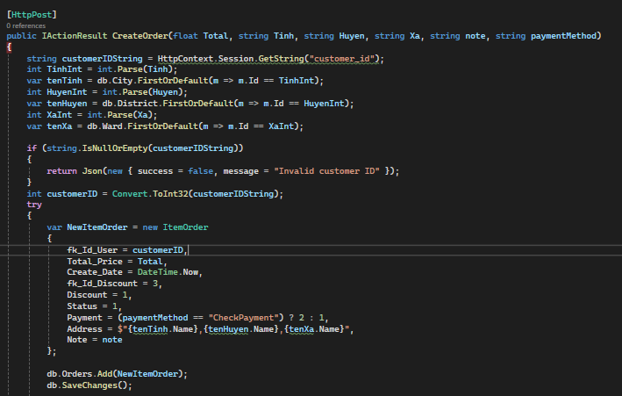

**Figure 3.20** Check payment method and get url VNPay

* + Payment Confirmation: After users confirm the payment on the VNPay website, the system will send a notification email to your Gmail confirming the payment, and the system will return to the website with a successful payment notification.

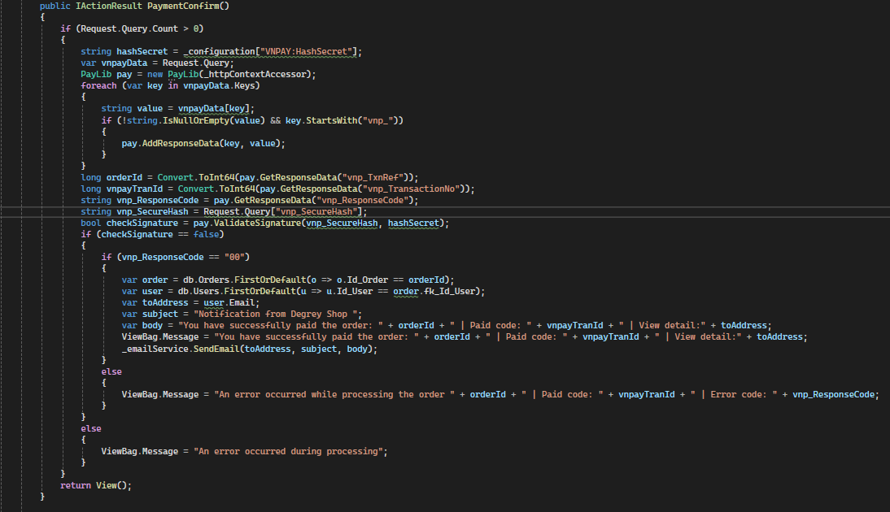

**Figure 3.21** Payment confirm

## Results

After the process of designing and building the website, I have built the admin page and client page

### **Admin pages (Admin)**

The admin interface, after the administrator logs into the system, will display a dashboard with statistics on the store's total revenue, the current number of users, the number of orders placed, and customer reviews.

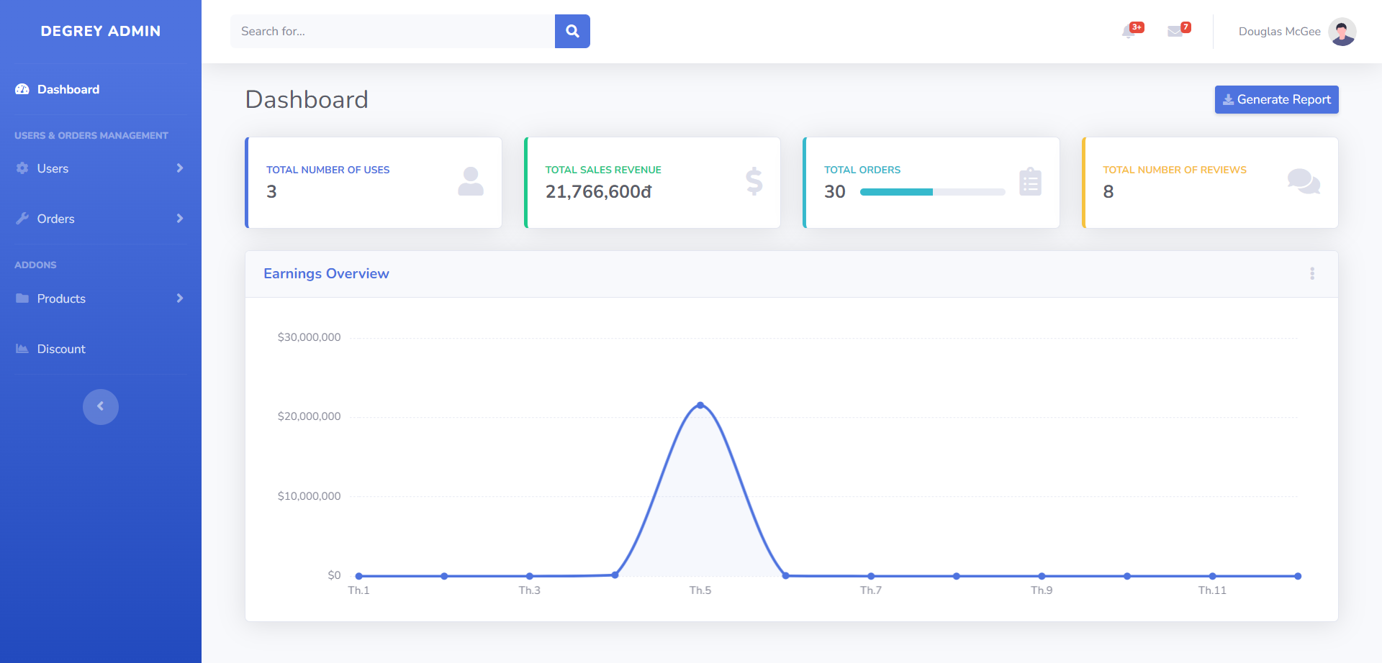

**Figure 3.22** Admin interface

The User Management interface allows the admin to modify user information, add a new user (normally an admin account), and delete accounts.

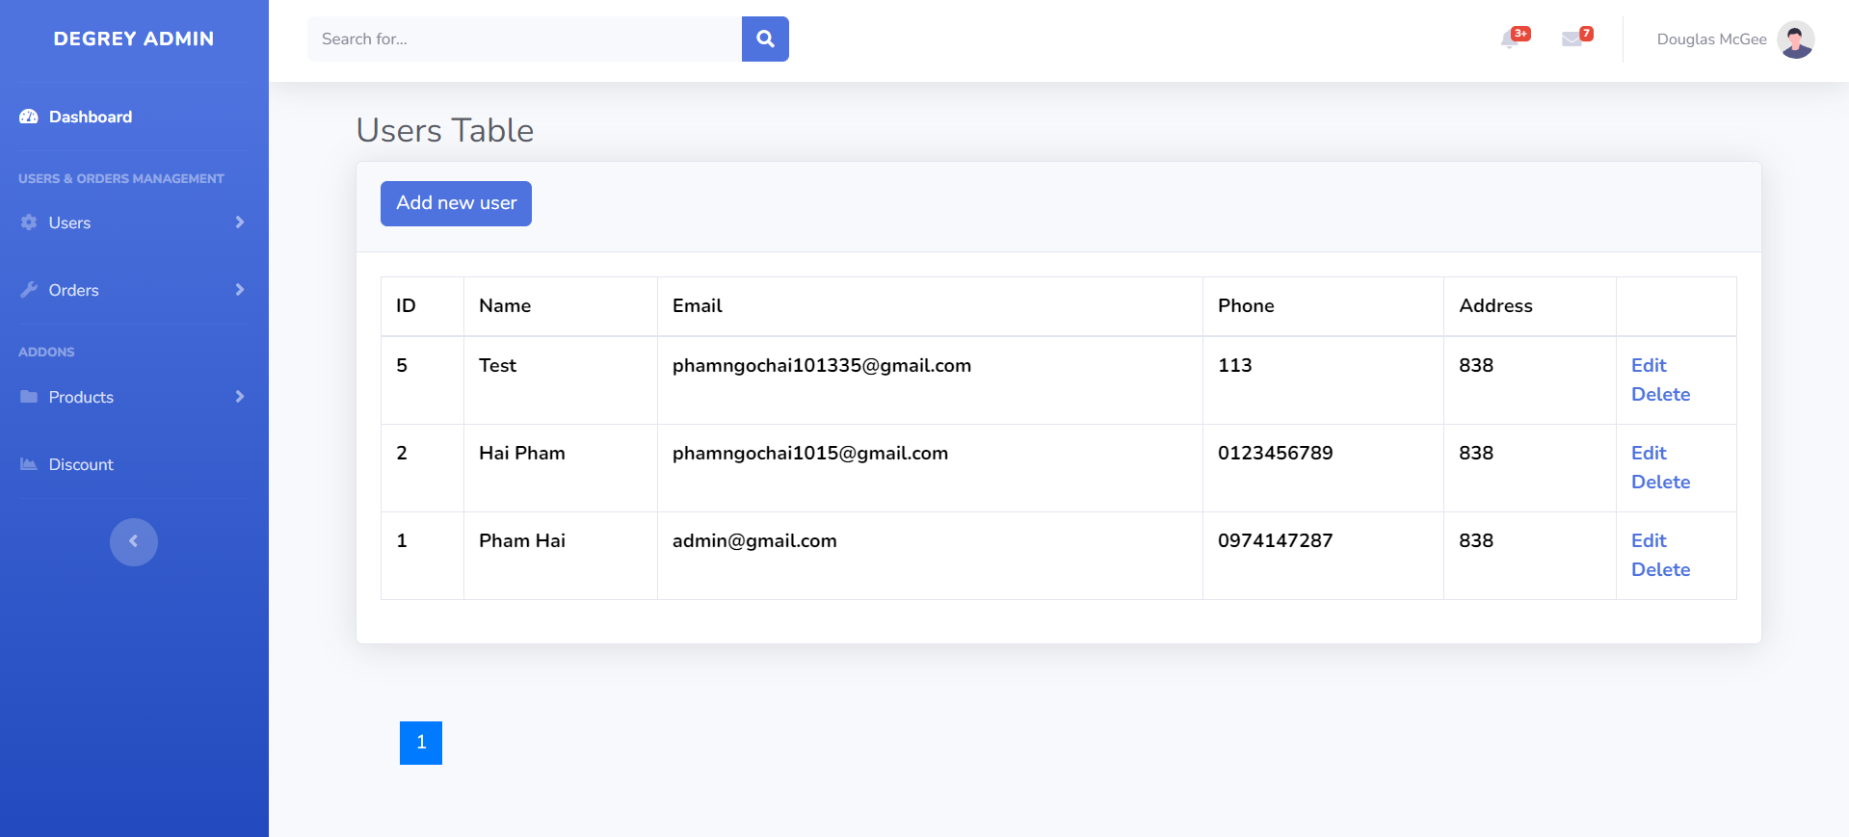

**Figure 3.23** Users management

With this interface, the administrator can view all orders placed by customers, change the order status (Accept, cancel by shop), or view order details.

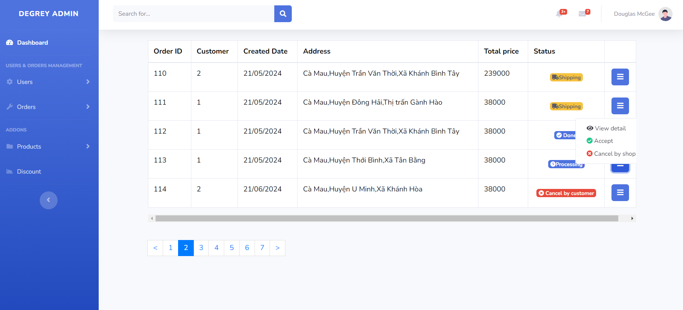

**Figure 3.24** Orders management

This interface allows the administrator to add new products, edit existing product information, add and edit color and size information for products. Additionally, the administrator can delete products, colors, and sizes.

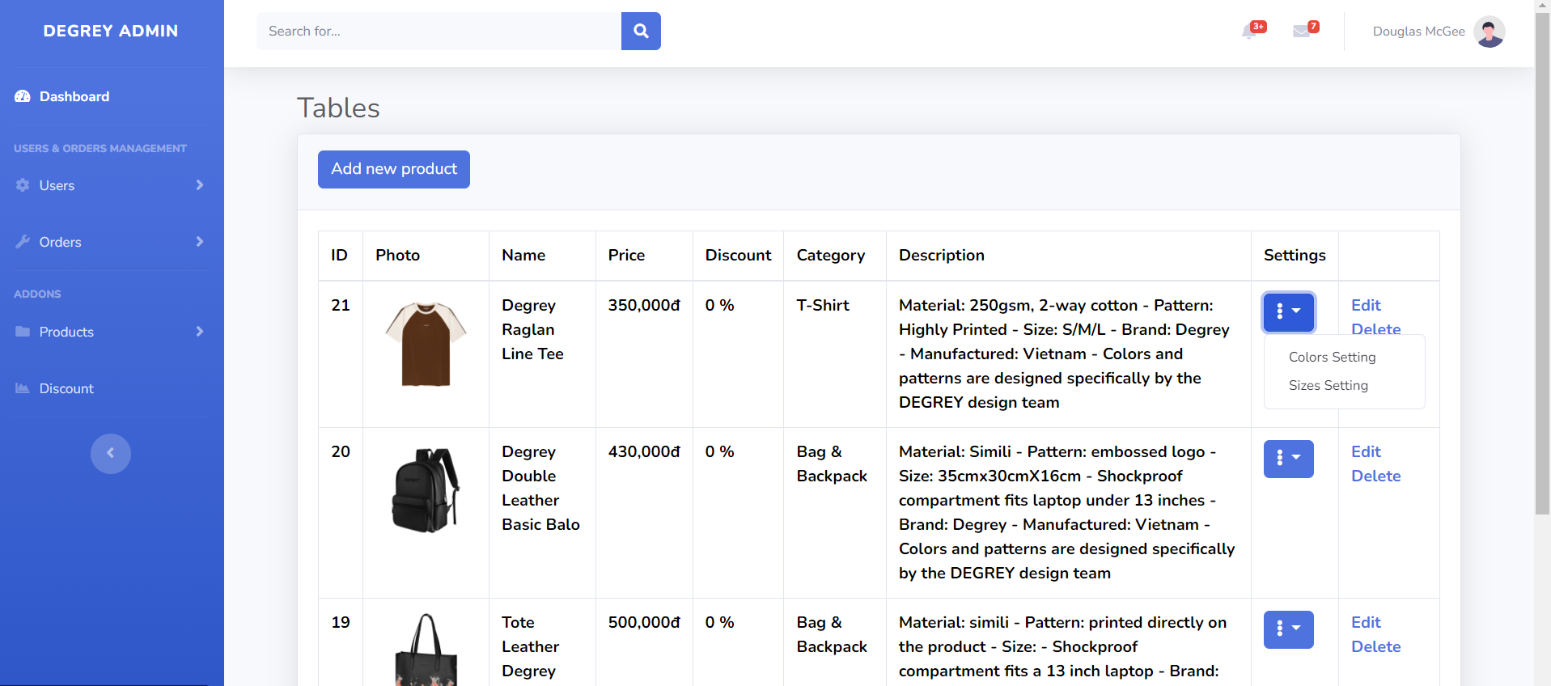

**Figure 3.25** Products management

With this interface, the administrator can add a new discount code, edit the information of any existing discount code, and delete it.

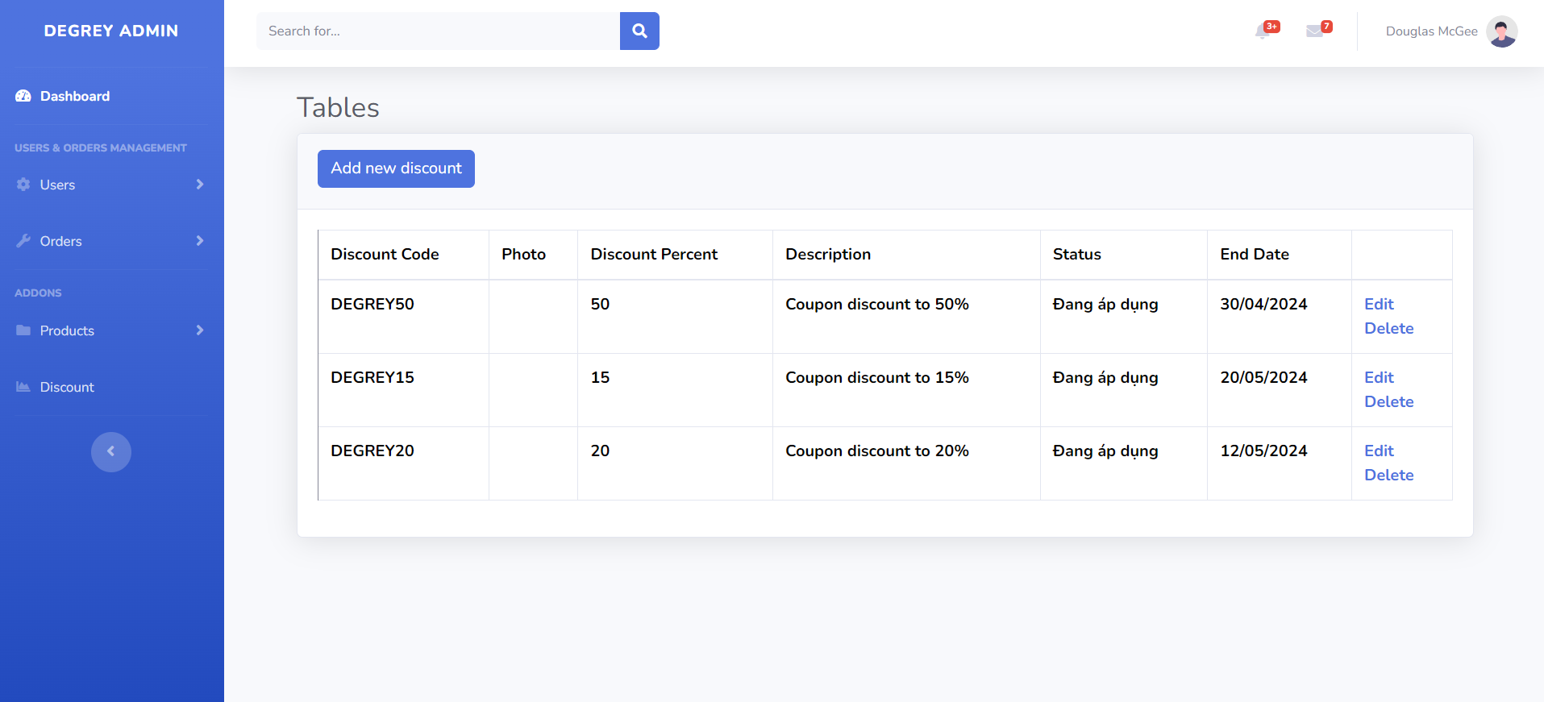

**Figure 3.26** Discount codes management

### **Client page (Customers, Guests)**

The user homepage interface enables users to view top-selling products, discounted items, and store promotions on sliders. Additionally, users can utilize the menu bar across all pages to access various sections: Products, Store location, About us, search for products by name, view their order history, and manage their shopping cart. Users can also log in and register for an account.

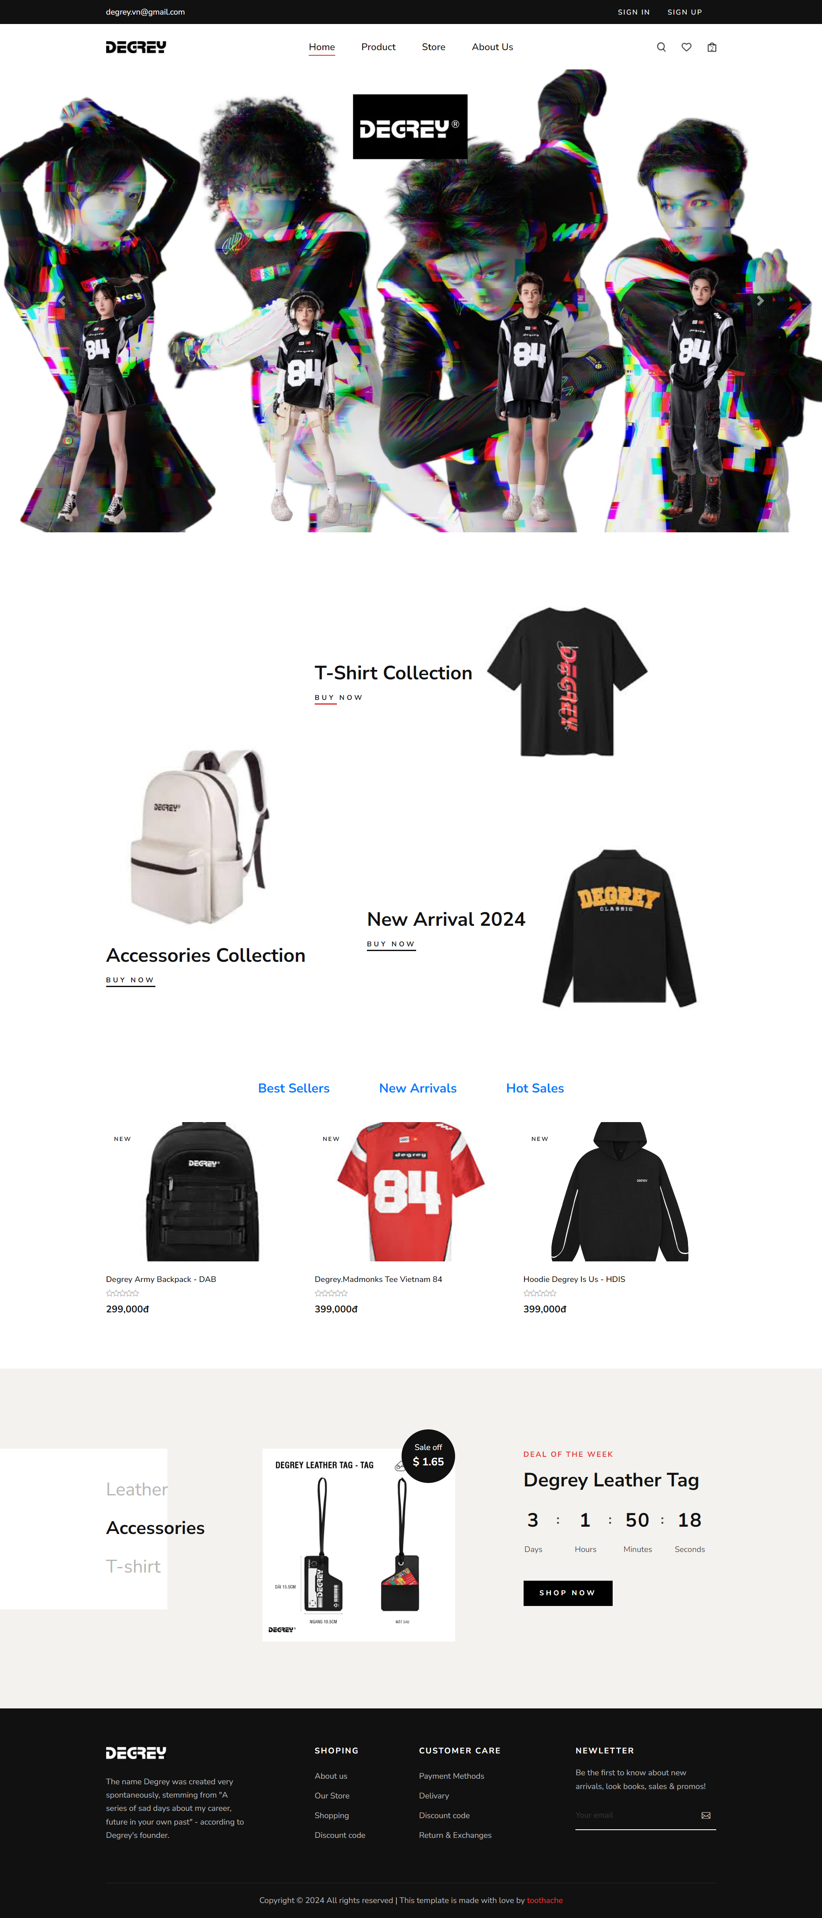

**Figure 3.27** Client Homepage

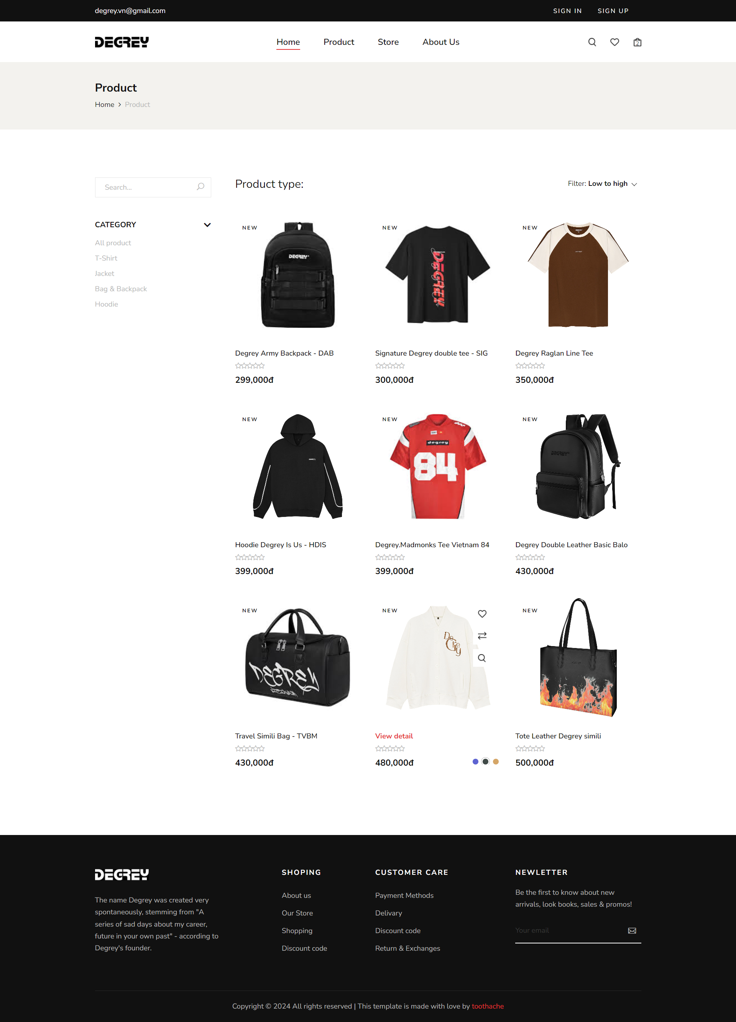

**Figure 3.28** Products Page

In this interface, users can view all products available in the store, access the detailed page for each product, filter products by category, and sort them by price from high to low or vice versa.

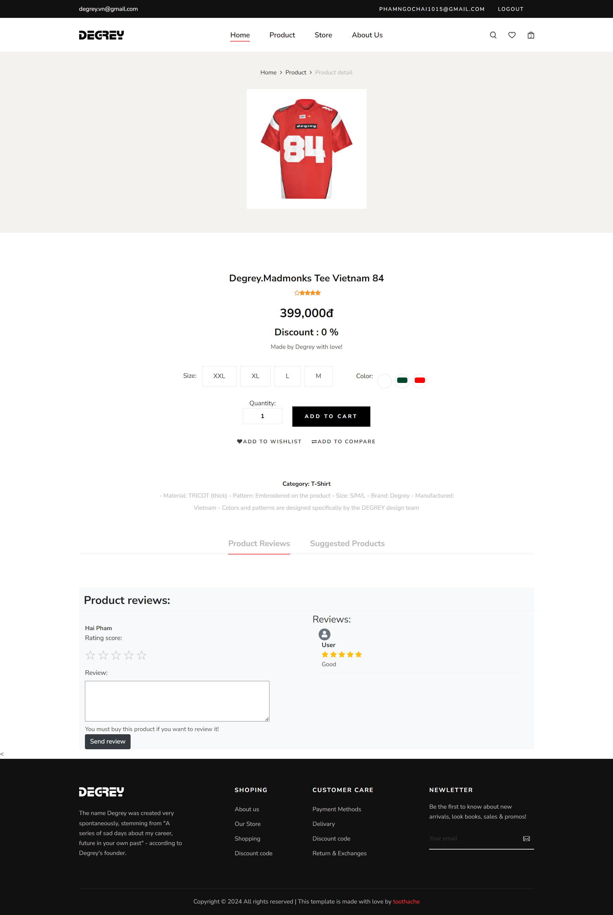

**Figure 3.29** Product detail page

In this interface, users can select the size, color of the product, specify the quantity, and add it to their shopping cart. Users can also view the product description, reviews, and explore similar products based on categories. If users want to review a product, they are required to log in and have purchased the product.

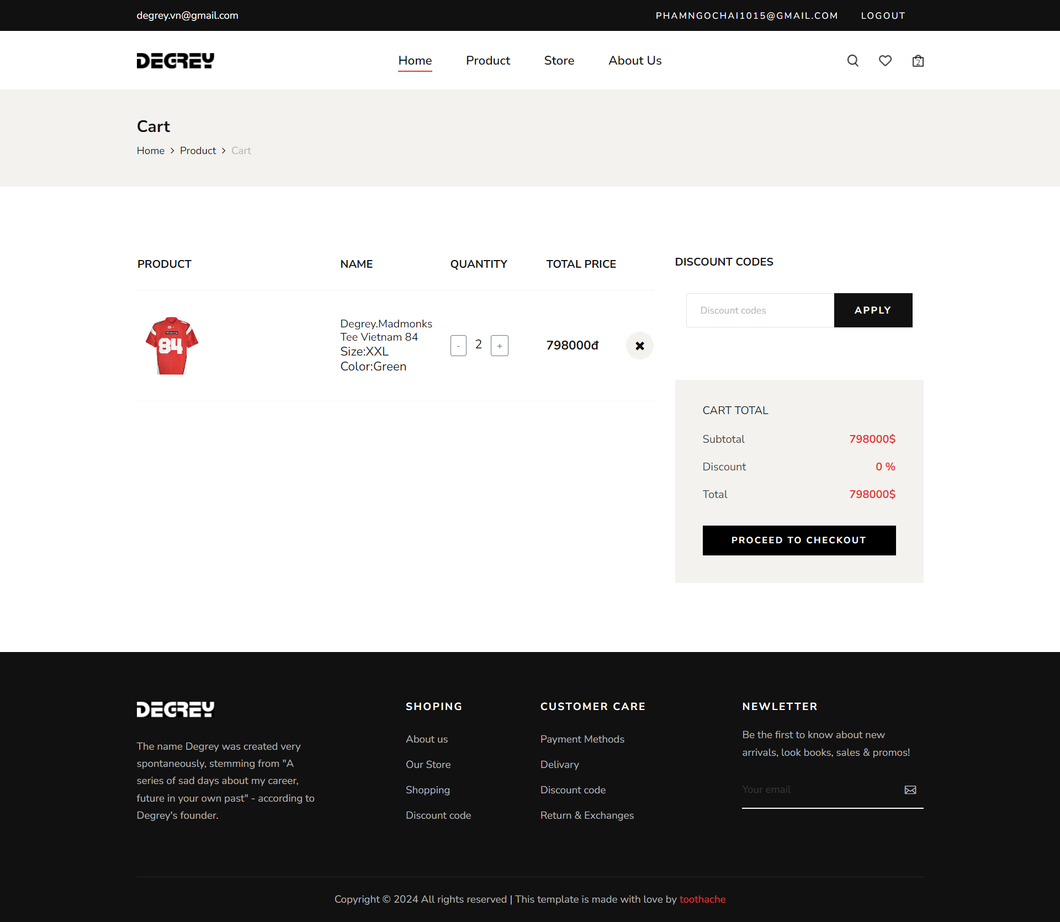

**Figure 3.30** Shopping cart page

In this interface, users can adjust the quantity of products, remove items they don't want to purchase, input store discount codes, and press "Proceed to checkout" to proceed to the checkout page.

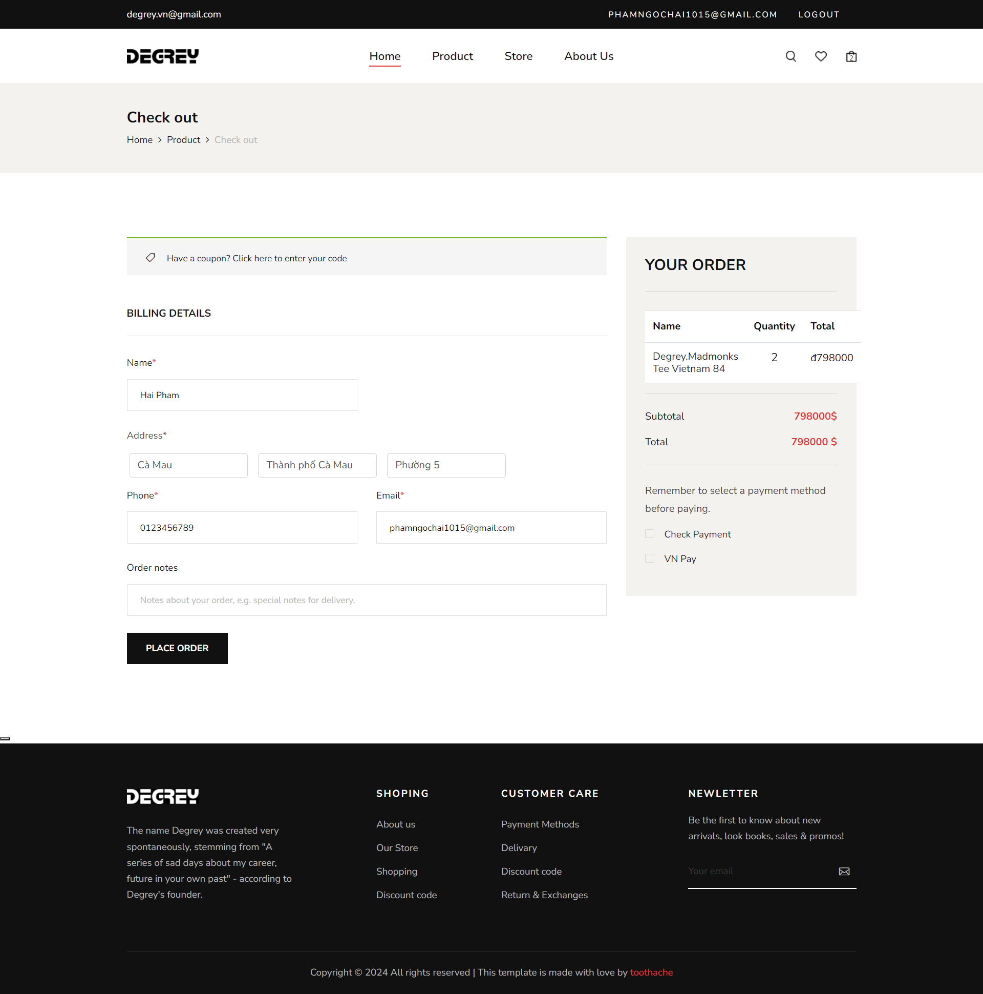

**Figure 3.31** Checkout page

After clicking "Proceed to checkout," this interface will appear. User information such as name, phone number, and address will be displayed based on their logged-in account. Users only need to select the delivery address and add any notes (if applicable). In the next step, users will see the total amount to be paid and will have two payment options: cash payment and VNPay. If cash payment is chosen and the payment button is pressed, the screen will display a successful order placement. However, if the user selects VNPay, upon clicking the payment button, they will be directed to the VNPay payment page. Upon completing the payment, a screen will show the successful payment along with the payment code, order code, and an email confirming the successful payment sent to the user's Gmail.

# CONCLUSION

1. **Results achieved:**

After the project implementation period, I have accumulated and significantly reinforced my knowledge about the website development process as well as design, development, and construction skills. The project successfully applied the UI/UX design process to website design. The system operates efficiently in all functions, allowing users to access and use it easily. The user interface is friendly and easy to use. Finally, this is a website that can run in real-world environments and is ready for future deployment.

1. **The limitations of the project:**

The website still lacks many of the functions mentioned above that have not been completed, such as Wishlist, price range filtering, etc. These functions can be further divided and developed to optimize the user experience.

The new project is still in the testing phase, so the security level as well as the speed are still slow for practical use.

1. **Future development directions of the project:**

The project can be further developed to include a function allowing users to edit their personal information. It can also be developed in the direction of deeper research into the customer market, the fashion preferences of young people, and customer needs to add functions that closely meet user requirements.

The website can be enhanced with more login platforms through Facebook, Google, etc. Additionally, it can develop customer tiers with various benefits and discounts for higher-tier customers to stimulate consumer demand.

Moreover, the website can be improved to include calculations of products by color and size available in stock, making it easier for the store's order processing and enhancing the shopping experience for users.

# REFERENCES

1. <https://capidemy.com/news/kham-pha/ui-va-ux-giong-nhau-biet-mot-lam-duoc-hai>
2. <https://www.youtube.com/watch?v=f1VYYjEhX2Q&list=PLZ52njWO5oxKNf7ZxH1YjH4lU80QefcZH>
3. <https://telos.vn/mau-figma-template-cho-landing-page-chat-luong/>
4. <https://chatgpt.com>
5. <https://gemini.google.com/>
6. <https://stackoverflow.com/questions/67297354/http-error-500-0-asp-net-core-iis-hosting-failure-in-process-in-dot-net-core>
7. <https://stackoverflow.com/>